CMPUT 366 Notes

* Reasoning vs Acting
  + Acting Humanely, we occasionally use the Turing Test
    - Don’t define what makes a system intelligent
    - If you act intelligently enough the others can’t, tell you apart form other people, then you are intelligent. But is this what we want?
  + Acting Rationally: Doing what is most likely to achieve our goal
    - +:
      * More defined than human behaviour
      * Prefer rational behaviour than irrational human behaviour
      * Easier to define than rational thought
* Mimicking humans vs rationality
  + Mimicking Humans is the idea of modeling the cognitive process of humans
    - +:
      * Intelligent
      * Scientifically valuable
    - -:
      * Difficult
      * Think in ways not intelligent
  + Rationality: An ideal of what intelligent cognition should do
    - Benefits:
      * More Agents
      * Philosophically important
      * Don’t just do what people do
    - -:
      * Difficult to define formally
* Agent: System that acts in an environment to achieve goals or optimize preference
  + Takes in Prior knowledge, goals/preferences and observations from the environment and then performs actions on the environment
* Knowledge: Info about domain which can be used to solve problems within said domain
  + Computational agent encodes it into set of structures called a representation. This can be about the environment:
    - States in world + denotation
    - Info about past and present states
    - Dynamics: How does environment change based on actions
* Representations must:
  + Be rich enough to express knowledge necessary to solve task
  + Close to problem
  + Tractable: Amenable to efficient computation
  + Learnable: Get new knowledge from data. Previous experiences and people
  + Trade of accuracy and time
* 3 Major Dimensions
  + Uncertainty
    - Either be Deterministic (Not random) or Stochastic (Some randomness)
    - Observations are either fully or partially observable with the former meaning observations directly determine state whereas the latter means that many states for same observations/misleading observations
    - The dynamics effect uncertainty and can either be Deterministic (state determined by action and prior state) or Stochastic (probability distribution over possible states from action)
  + Interaction
    - When agents decide what to do. Can be either “
      * Offline: Before interacting with environment
      * Online: While interacting with environment
  + Num of Agents
    - Consider other agents?
    - Single:
      * No other agents in environment/behaviour of other agents are fixed
    - Multiple:
      * Other agents in environment have distinct goals
      * Must reason about other agents’ behaviour and reasoning
      * Other agents’ actions affect agents’ goal/preferences and vice versa
* Other dimensions:
  + Static vs Sequential
    - How many actions?
    - Static:
      * Single action
    - Sequential: Sequence of Actions
    - In deterministic settings: Can be arbitrary
  + Goal vs Preference:
    - How complicated goal is?
    - Goal: Desired condition
      * Maintenance Goal: Keep some already true condition true in all visited states
      * Achievement: Final state condition must be true
    - Preference: Varying desirability of different outcomes/trade offs
      * Ordinal: Only ordering of outcomes is important
      * Cardinal: Magnitude of preference also matters
  + Knowledge given vs learned:
    - How much do agent know about world in advance:
      * Agent has a model of world prior to acting
      * Must learn how world works from:
        + Data
        + Experience
        + Prior knowledge
  + State representation:
    - How does it describe the world?
    - Enumerate every possible state
    - Factor each state into features
      * May or may not be observable
    - Relationships and objects
  + Episodic vs Continuing:
    - Is task done
    - Episodic: Eventually reaches final state
    - Continuing; Continues to act forever
  + Perfect vs Bounded Rationality:
    - Feasible to achieve ideal optimal or must it trade off solution quality against computation
    - Perfect: Can derive the best course of action without taking computational limits into account
    - Bounded: Takes best action it can find within computational limitations
* Easier to recognise a solution than compute it
  + Searching Fully-observable, deterministic, offline, single-agent problems exploit it
* Agent searches internal representation to get solution
  + Computation integral to agent
  + Environment is fully deterministic
* Better to represent problem as a directed graph as it is very general
* State: Describes all relevant info about possible configuration of environment
* Markov Assumption: How environment got to a given configuration doesn’t matter just current configuration
* Actions: Change environment from one state to another
* Search problem is compromised of:
  + A set of states
  + Start State
  + Set of actions at each state
  + Successor function which maps a state to the next set of states
  + Goal function which returns true when state satisfies the goal
  + Goal State
* Solve Search problems:
  + Consider start state
  + Consider ever state that can be reached from some state which has been already considered earlier
  + Stop when reaching goal state
* Directed Graph is a Pair G= (N , A) where N is a set of nodes and A is a set of ordered pairs known as arcs
  + An arc connects to neighbor nodes
* A path is a sequence of nodes n1🡪nk where ni -1 and ni form an arc and a solution is a part from start to goal node
* Search Problem=Search Graph where:
  + Nodes are states
  + Neighbors are successors of a state
* Graph Search Alg
* Given graph start and goal node, incrementally explore paths from start nodes
* Maintain a frontier of paths explored which expands into unexplored nodes as search proceeds till a goal is encountered. They way it expands determines the search strategy

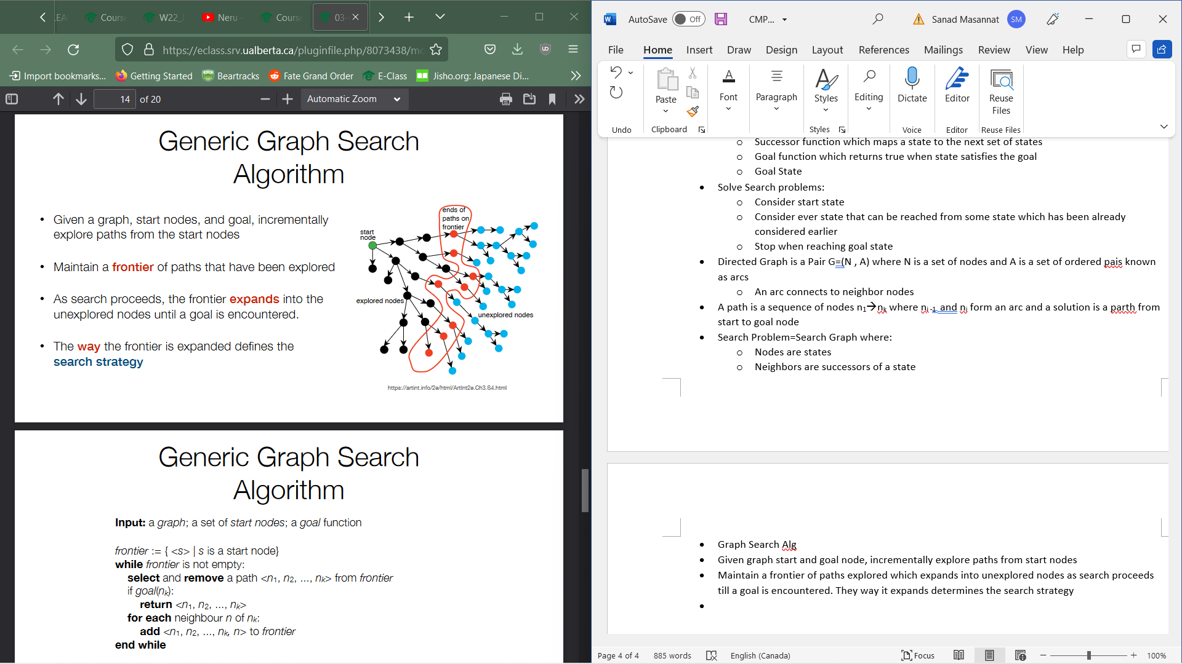

* Pseudocode:



* We can add costs to arcs and the cost of the solution would be the sum of all the arcs in path. Thus, the optimal solution minimizes this cost.
* Depending on if the Markov Assumption is satisfied or not, the scheme is either sufficiently or insufficiently general
* We can use this if we only care about number of actions taken by adding a cost of 1 to all arcs or if we only care about the quality of solution
* Markov assumption is very important for graph search algs
* A search alg is complete if it finds a solution whenever a solution exists
* Time complexity is a measure of how much time alg takes to run in worst case
  + Total number of paths added to frontier
* Space complexity is a measure of how much space alg will use in worst case
  + Max num of paths in frontier at one time
* Properties of Search Graph:
  + Forward branch factor: Max num of neighbors (b)
  + Max path Length (m)
  + Cycles present
  + Length of shortest path to goal node
* Depth First search



* + One data structure you could use is a stack
  + Always remove one of the longest paths from frontier



* + <P1,N3> is selected after p1,n2 is removed
  + Time Complexity is O(bm) order of branch factor to power of m because in the worst case, you could pick all the incorrect paths first
  + It will guarantee to stop if there are no cycles and if m is finite.
  + Space Complexity is O(bm)
  + Use when:
    - Memory is restricted
    - Solution at same approximate depth
    - Order in which neighbors are explored can be tuned to find solution factor
  + Do not use when:
    - Infinite paths
    - Shallow solutions especially if other solution are deep
* Breadth First Search:



* + Use a FIFO queue for frontier
  + Time complexity is O(bm) as it would have to search all the incorrect paths before it
  + It is complete when isn’t infinite
  + Space complexity is O(bm)
  + Appropriate when:
    - Infinite pats
    - Shallow solutions or
    - Guarantee solution with fewest arcs
  + Not appropriate when:
    - Large branching factor
    - Solutions deep in tree
    - Restricted memory
* Iterative Depth First search:



* + Time complexity = O(bm), still must look at all the paths
  + It is complete when branch factor is finite, and solution is of finite length
  + Space Complexity= O(bm)
  + Appropriate:
    - Limited memory and both deep and shallow solutions exist
    - Infinite paths
* Above algs are determined by oath length rather than arc cost
* Alg is optimal if it returns an optimal solution first (Breadth, Depth and Iterative Depth are not optimal)
* Least cost search is optimal as it looks at arc costs

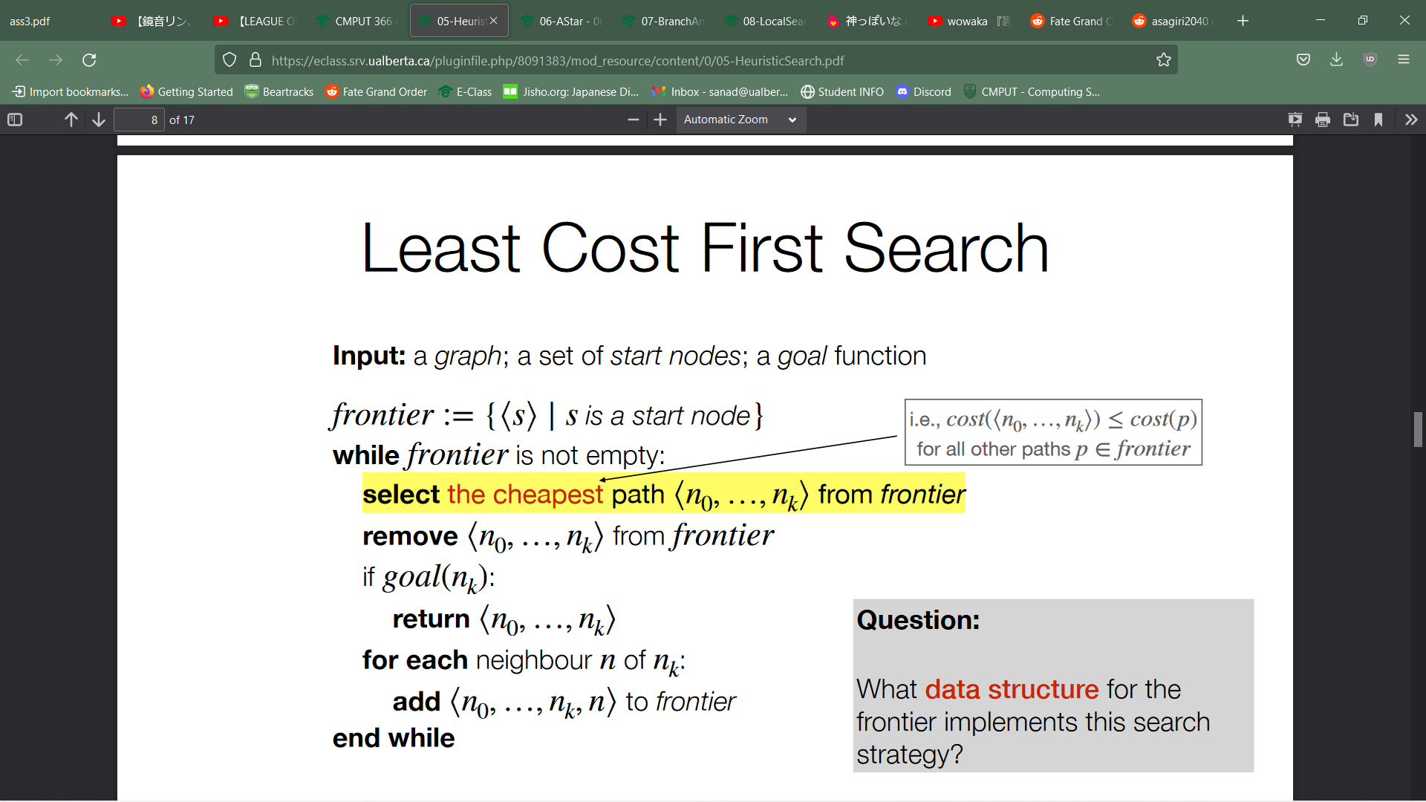

* + Heap and Priority queues can be used



* + Space Complexity is O(bm) as we still may need to explore every path



* By identifying promising directions, and using domain specific knowledge we can speed up search
* Heuristic Function estimate the cost to get from a node to a goal node. This is used when selecting a path from a frontier
  + This is a type of function which returns a non-negative estimate of cost of cheapest from node n to goal node
  + It is admissible if h(n) is always less than or equal to the cost of the cheapest path from n to goal (Euclidean)
* To construct an admissible heuristic
  + Drop some constraints of search graph
* A* uses path cost info and heuristic info to select a path
  + F(p) = cost(p) + h(p)
  + Removes path with smallest f(p)





* + For frontier, use a stack
* A* Theorem:
  + If solution of finite cost exists, A* with heuristic h will return an optimal solution if:
    - Branching factor is finite
    - H is admissible and
    - All arc costs are greater than ε>0



* + 
* A heuristic g dominates a heuristic h if
  + For all n: g(n)>=h(n) and for some n g(n)>f(n)
  + If g dominates h and both are admissible, A* using g will never remover more paths from frontier than A* using h
* Space complexity of A* is O(bm) while time complexity is O(bm)
* 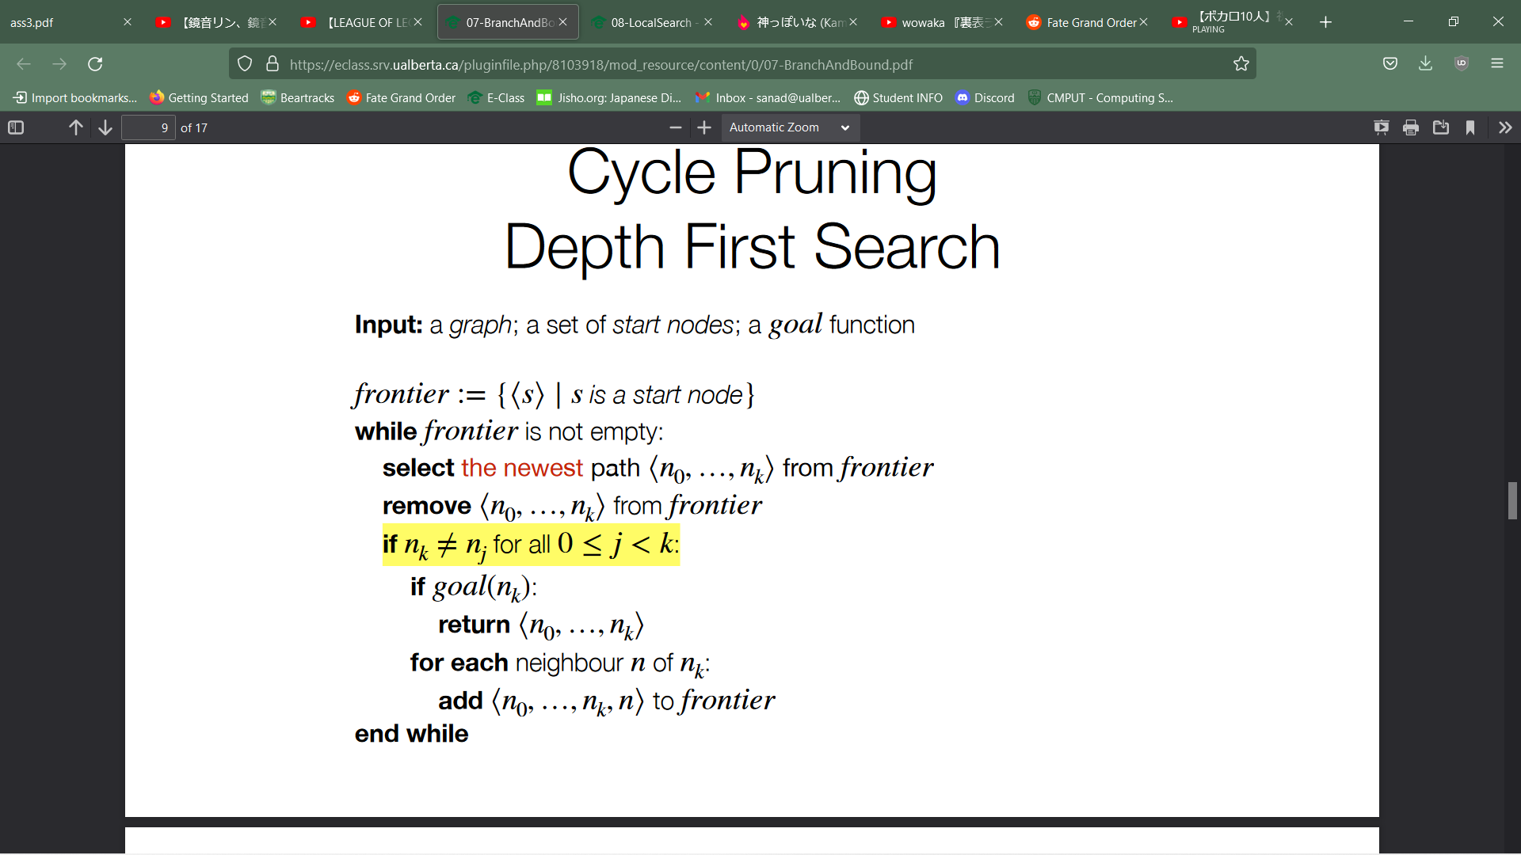
* Depth first search is liable to get trapped in a cycle
* A search alg can prune any path ending in a node already on the path without missing the optimal solution
* Branch and Bound
  + F(p) function provides a path specific lower bound on solution cost from P



* + If Bound 0 is above optimal cost, B&B will not explore no more paths than A*
  + With iterative increasing of bound 0, will re-explore lower cost paths wile having similar time-complexity to A*. Increase bound to lowest f value node that was pruned. Worse than A* by no more than a linear factor of m
* We can search backwards if we are trying to find the path to a known goal



* Bi-Directional search is the idea to search forward from start and backwards from goal
  + Time complexity = exp (path length) so despite exploring path length 2 times, we get an improvement
* Problem is when checking if frontiers met and guaranteeing they do.
* Sometimes to recognize a goal node, but not construct one
* State: Values of different values
* Easy to recognize when we’ve succeeded but getting a satisfying assignment is NP-complete

Constraint Satisfaction Problems: A problem that requires its solution to be within some limitations or conditions, also known as constraints, consisting of a finite variable set, a domain set and a finite constraint set.

* Sometimes, constructing a graph search problem can give us too big of a space or we wont care about action sequences
* Local search is the idea that we start from a random assignment and then search around the space of possible assignments without keeping track of sequence
  + Select Assignment
  + Repeat: Select a variable to change and a select a new value for that variable until satisfiying assignment is found
* Local Search Problem:
  + A constraint Satisfcation Problem is a set of variables, domains for variables and constraints on joint assignment
  + Neighbour function maps a node n to similar nodes
  + Score function evaluates quality of an assignment
  + Nodes are the states (assignment of values to variables)
  + The goal nodes would be the nodes which satisy all constraints
  + Neighbor function is a design choice
  + We choose actions which help us efficiently explore the space rather than trying to represent actual actions
  + Nieghbourhood is states that differ in small way from previous node
  + Scores are required
    - State Space is too big
    - Not always a goal exists, we want to maximze state quality
  + Alg:



* Hill Climbing:
  + Select Neighbour with highest score(improvement step) and if no improving steps are available, stop and return incumbent(highest value found)
  + Seeks highest point and only goes uphill
  + 
  + It is not complete nor optimal



* Random Algs:
  + Add random moves to fix above problems
  + 2 main kinds:
    - Random Restart: Start from a completely new random locaction
    - Random step: Choose a random nieghbor
  + Stoachistic Hill Climbing: Adding both moves to hill climbing
  + 
  + It is complete(you are bound to randomly get the correct value despite length) but not optimal (it can immediately return the best thing it has found which isnt optimal or something satisfying)
* Simulated Annealing:
  + Start by searching randomly but becoming more direct(move to a good neighborhood quickly and search intensively there)
  + Maintain a Temp T and choose new nodes more randomly at higher T
  + Each Step:
    - Randomly choose a new neighbor new
    - Always accept if score of new is better than score of current, else accept with probability exp((score of new – score of current) / T)
* Agent cant make assumptions and act on those (Usually has perfect knowledge of world and dynamics)
* Knowledge is uncertain:
  + Multiple hypothesis
  + Update beliefs about which hypotheses are likely given observations we find
* Uncertainity(not truth) measured by probability (between 0 and 1)
  + Objective statements about world. This view is frequentist
    - Probability of event is proportion of times it would happen in long run of repeatd events
    - Every event has a single true probability
    - One time events don’t have a well defined probability
  + Subjective Statements about an agents belief
    - Porbability of event is measure of agents belief about its likelihood
    - Diiferent agents= different beliefs = different proabilities
    - Only one way to update beliefs in response to new data
* Random Variables take value from domains
* A possible world is a complete assignment of values to variables where a single world is $ω$ and set of all possible worlds is Ω
* Probability measure if a function P: Ω 🡪R over possible worlds $ω$ satsifying:
$\sum_{ω∈Ω}{P\left(ω\right)}=1$

$P\left(ω\right)≥0 ∀ω∈Ω$

* Primitive proposition is an equality
* A proposition is built up from other propositions using logical connecters (And or not)
* Probability of propostion is the sum of probabilities of the possible worlds in which proposition is true:
  + - means a is true in $ω$
* Joint distribution is the same as P(A AND B) or P (A,B)
* Marginalization is using the Joint distribution to compute distribution over smaller number of variables
  + Smaller dist is called the marginal dist of variables
  + P(X,Y)= $\sum_{z∈\operatorname{dom}\left(Z\right)}{P\left(X,Y,z=z\right)}$
* Conditioning
  + Update belies based on new observations
  + Form P(A|B) (probability of A given B)
  + Evidence B lets us rule out worlds incompatible with e. We also need to normalize probabilities of worlds to make sure they sum to one
  + P(h|e) = P(h,e)/P(e)
  + Chain Rule
    - P(h,e)=P(h,e)P(e)=P(e|h)P(h)
  + Bayes rules:
    - P(h|e)= P(e|h)*P(h)/ P(e)
  + Expected value:
    - E[f(x)] = $\sum_{x∈\operatorname{dom}\left(X\right)}{P\left(X=x\right)f(x)}$
* P(H)= $\sum_{z∈\operatorname{dom}\left(Z\right)}{P\left(X\right)*P(H|x)}$
* Probabilities aren’t fully arbitrary
* We may need to explicitly specify joint distribution
* Unstructured: Enumerate entire joint distribution . These are hard to reason about
  + Generated by underlying process
  + Gives us structure that we can exploit to represent and reason about probabilities in a compact way
  + Compute required joint probabilities
* Marginal Independence: When value of one variable never gives info about other
  + P(X=x|Y=y) = P(X=x) and (Y=y |X=x) = P(Y=y)
  + P(X=x, Y=y) = P(X=x)P(Y=y)
* Conditional Independence : Knowing the value of a third variable Z makes A and B independent
  + P(X=x|Y=y, Z=z) = P(X=x|Z=z) for all x,y,z in X, Y Z
  + PX=x,Y=y|Z) = P(X=x|Z=z) P(Y=y|Z=z)
  + It is commutative
* Store Smaller tables
* When two variables are marginally independent, they are conditionally independent on a 3rd variable but not always true
* Belief Networks:
  + Nodes are random variables
  + Dependence in a distribution as directed graph
  + Arc to each node from variables in which it depends on
  + E.g.



* + Graph represents a specific factorization of full joint distibution
    - Distribution on each nde conditions on its parents
    - Marginal distributions on nodes with no parens
  + Every node is independent of its non-descendants. Conditional on parents
    - U is a parent of v if directed path u🡪 v exists
    - V is a descendant of u is a directed path exists beween the 2 and if not, it is non-descendant
  + Formal def:
    - Domain of each variable
    - Directed acyclic graph with node labelled by random variable
    - Conditional probability table for each variable given parents
  + Used to query posterior probabilities given observation



* + Guaranteed to exist at every step as it is finite and acyclic so there will always one node with no incoming edges
  + 
  + These are correct if it encodes true conditional independence relationships(All nodes are independent of non-descendants given parents)
  + Joint dist have many correct encodings but some are better than others



* + Observing a parent renders conditionally dependant nodes conditionally independent and Observing children can render conditionally independent nodes  
    conditionally dependent
* Causal Networks
  + Arcs in belief network don’t represent causal relationships( B🡪A is causal if B causes value of A)
* Joint distribution can be factored in multiple ways
  + Every variable ordering induces one correct factoring via chain rule
  + Belief network represents single factoring in which some are correct/incorrect
  + A given variable ordering does not correspond to a unique factoring
* 
* Every node is independent of its non-descendants, conditional only on its parents
* 
* 
* A belief network is a correct representation of a joint distribution when the belief network answers yes to an independence question only if the joint distribution answers yes to same question
* Variable elimination alg exploits factorization of join probabilities encoded by belief network to answer queries
  + Factor is a function f(X1🡪Xk) from random variables to real number
  + P(A|B) becomes F(A,B)
  + Aims is to get a new factor encoding posterior dist
  + 
  + Conditioning is an operation on a single factor with some of input fixed
    - 
    - E.g Conditioning on A=True: f2(B)=f1(A,B)
  + Multiplication on two factors return product of the rows selected from facots by args

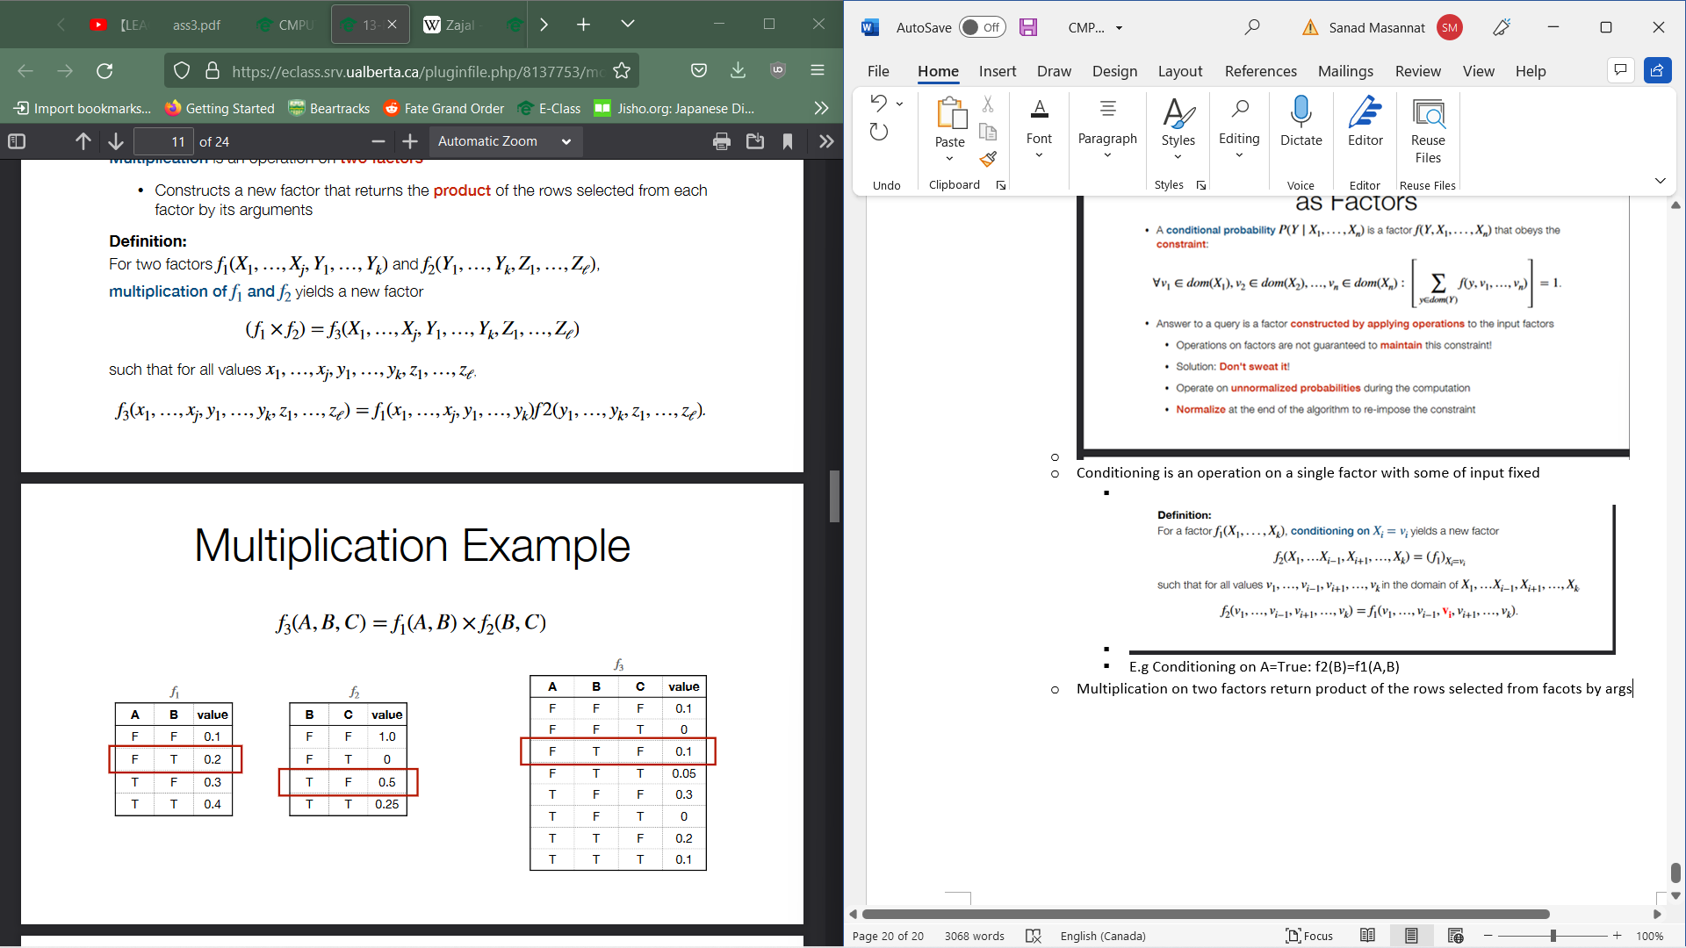

* + Summing out is an opration on a single factor and constructs a new factor which returns the sum over all values of a random variable of original factor
    - 

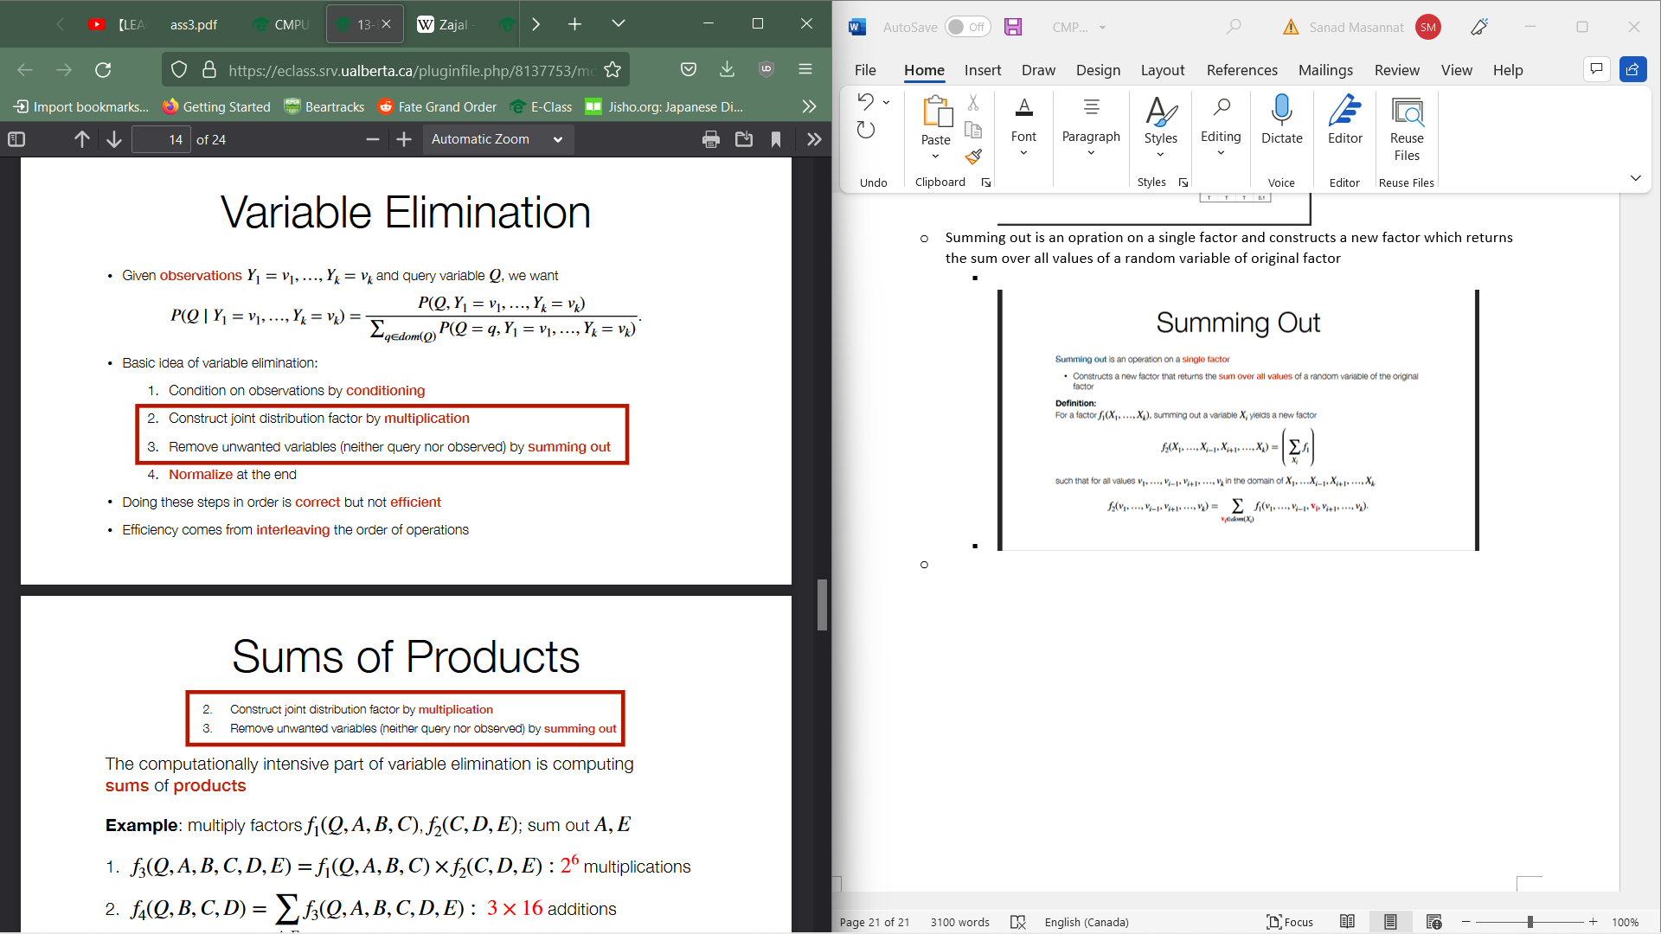

* + Sum of products is computationally expensive
  + To get computations its 2 to the power of number of variables in output factor
  + Swiching order reduces computations sometimes
  + 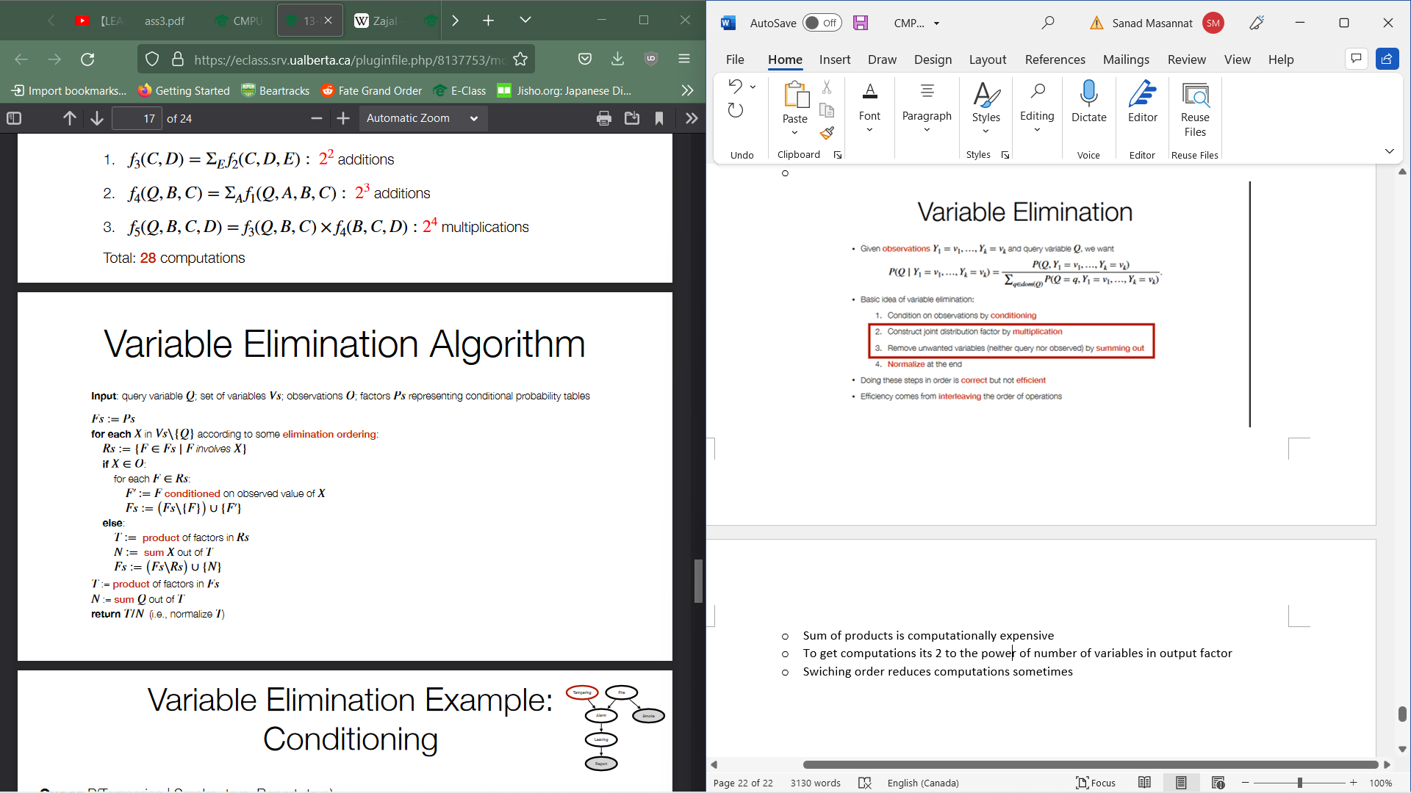
  + To get query(variable)🡪 factor(variable)/sum(variable)
  + Exploits efficient sum of products on factored joint dist
  + Finding optimal elimination is NP-hard
  + Heurisitcs:
    - Observations first: All observed variables first
    - Min Facot:select smallest min factor
  + We can drop leaf nodes that arent observed nor queried
* We can proprocess graph:
  + Precompute joint distribution
  + Precompute conditional distributions for exact query
* Recall that there are two different wau t factor joint distribution of two variables
  + P(A,B) = P(A|B)P(B)=P(B|A)P(A)
* Different factorization= Different belief network
* Could preproccess natural network into a form to avoid lots of computations with Bayes Rule
* However, sometimes we get weird examples( If we throw water ona sidewalk, we are saying it will more likely rain given sidewalk is wet)
* Belief networks are defined by observational queries whereas they don’t directly model causal questions
* Simpsons paradox: an effect that occurs when the marginal association between two categorical variables is qualitatively different from the partial association between the same two variables after controlling for one or more other variables
  + 
  + Selection Bias: Whether subjects received treatment is systematically related to respone to treatment
    - Use Radonmized trials to avoid this
* Causal query is a query on a distribution in which we have a forced variable(Post distribution)
  + Different from conditioned on observing that variable (Observational)
  + When forcing a distribution, we remove the line of the conditional distribution in which we force the variable
  + E.G:
    - 
* We use do calculas to express causal queries
  + P(Y| do(X=x) ) expresses interventions
* Given Query P(Y| do(X=x), Z=z )
  + Construct post intervention distribution P_Hat by removing links from X’s dierct parents to X and then evaluate the observational dist P_Hat(P(Y| X=x, Z=z ) in post intervention dist
  + 
* Naural network gives correct answer to causal query but inverted doesntt
* Not every factoring of joint dist is a valid causal model
* Causal Model:
  + Directed Acyclic graph of random variables such that fro every X🡪Y, the random variable X is realized before value of Y
  + We can represent causal queries by augmenting model with decision vairables FD for each intervention target D
* Supervised learning is made up of:
  + Input Features (X1🡪Xn)
  + Targe Features (Y1🡪Yk)
  + Training examples, for which both input and target feaures are given
  + Test examples for which only the input features are given
* Aim is to predict values of target features given inout features
  + Classification if Yi is discrete and if they are real-valued, then regression.
  + Interpolation: Within range and Extrapolation: Outside of range
* Real-valued features: We just record feature values
* Discrete features:
  + Binary features: Can code as 0,1 or -1,1
  + Numeric:
    - Cardinal: Differences are meaningful
    - Ordinal: Order is meaningful
    - Categorical: Neither are important
  + Vector of indicators: One feature per value where exactly one is true
* We want to be able to make correct predictions on unseen data
  + Can sacrifice training accuracy for this
  + Generalize: Go beyond the given training examples to classify new data
  + We can estimate generalization performance by evaluating test set performance as we have access to test data but algorithm doesn’t. We also assume the training distribution and the unseen data distribution are the same
* A preference of one hypothesis over the other is bias(not a bad thing)
* Fiven training data, hypothesis spce, error measurement and bias, learning can be reduced to search
* Learning search eshypothesis space(possible hypothesis) to get best hypothesis for data given bias.
  + Search space large
  + Local search is most common ML method
* We choose hypothesis by measure performanceon training data and bias
* Usually minimizing error
* 0/1 Error
  + Correct value given 0 and incorrect value = 1 and error is sum of all those values. Best fot binary or categorical
* Absolute Error
  + Absolute sum of distance between predicted and actual value
  + Best for cardinal(Bad for categorical)
* Squared Error
  + Squared sum of distance between expected and actual
  + Best for cardinal
* Worst Case:
  + Take the absolute max of the differnece between predicted and actual
  + Cardinal
  + Only done for one example(the worst case as aptly named)
* Alg commonly predict probability distribution over possible values
  + Done for clarification tasks
* Vectors of indicator variables are the most common data representation for this scheme:
  + Target features of training examples have a single 1 for the true value
  + Predicted target values are probabilites that sum to 1
  + E.g
  + 
* Likelihood: For a data set E of examples and hypothesis $\hat{Y}$, the probability of independently observing the examples according to probabilities assigned by hypotheis is :
 $\operatorname{Pr}\left(E\right)=\prod_{e∈E}{\hat{Y}\left(ⅇ=Y\left(ⅇ\right)\right)}$

 + Product of Probabilities shrinks exponentially
* Log-Likelihood
  + For a data set E of examples and hypothesis $\hat{Y}$, the log probability of independently observing the examples according to probabilities assigned by hypotheis is :
  + $logPr\left(e\right)=log\prod_{e∈E}{\hat{Y}\left(ⅇ=Y\left(ⅇ\right)\right)}$ = $\sum_{e∈E}{log\hat{Y}\left(ⅇ=Y\left(e\right)\right)}$
  + Prevents floating point underflow
  + Grows monotonically
* Trivial Predictor: Simplest possible predictor ignores all input features and predicts the same value v for an example
  + 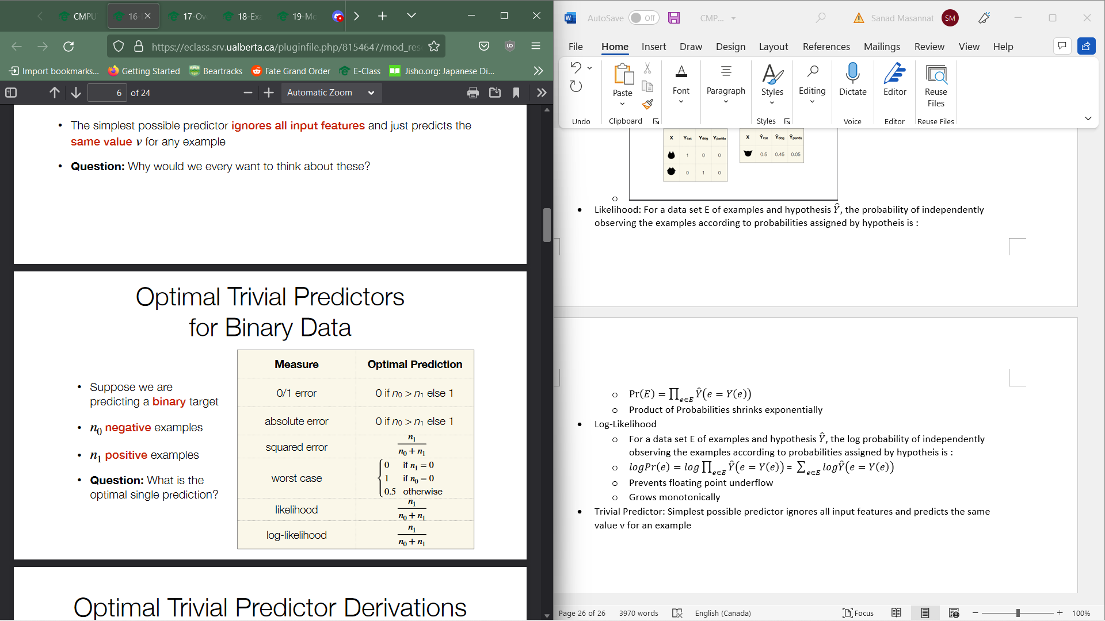
* Decision Trees:
  + Every internal node is labelled with a condition
  + Every internal node has two children, one labelled true and on labeled false
  + Leaf node is labelled with a point estimate on target
  + 
  + To choose a decision tree:
    - Bias: Which decision tree are preferable to others
    - Search: How can we search the space of decision trees
      * Search space is prohibitively large
      * Idea: Choose features to branch on one by one
  + Tree constructing algorithm :
    - 
    - The algorithm will stop when there are no more conditions, example or examples having the same label
  + Other possible criteria:
    - Minimum number of examples: Do not split a node with too few examples
    - Minimum child size: Do not split a node if there would be too few examples in one of children
    - Improvement criteria: Do not split a node unless it improves some criterion sufficiently
    - Maximum Depth: So not split if the depth reaches a maximum
  + Which point estimate go on leaves:
    - Modal target value
    - Median target value
    - Mean target value
    - Distribution over target values
  + Set of conditions are:
    - Boolean feature can be used directly
    - Partition domains into subsets
    - One branch for each domain element
  + Myopically optimal condition should be chosen to split on
* Linear regression is the problem of fitting a linear function to a set of training examples where both input and target features must be numeric



* Gradient descent is an iterative method to find the minimum of a function:
  + Wi+1 = w­I – η*δ/ δw­I error(E.w)
  + 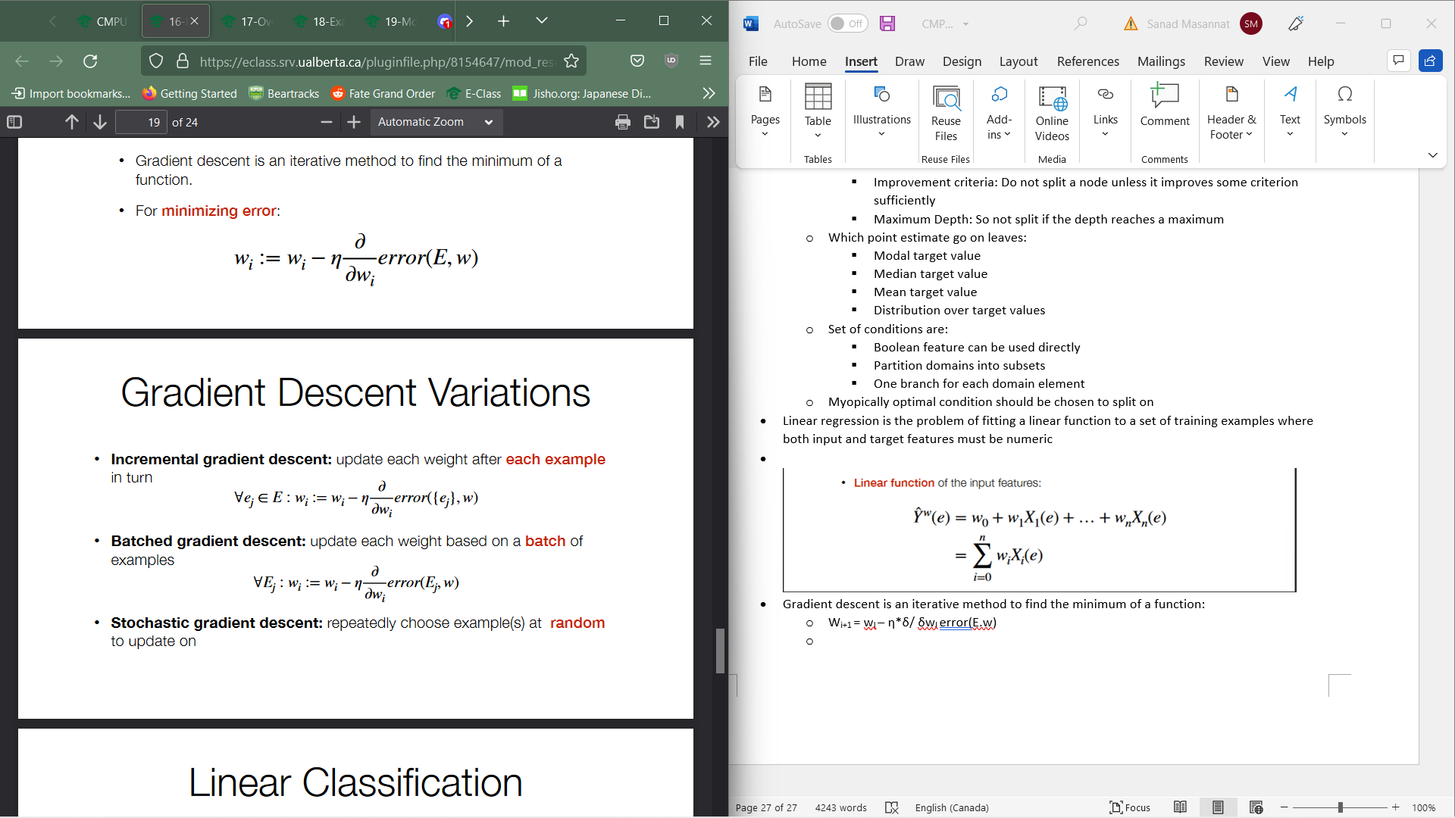  
    For linear classification, when using binary targets represented by [0,1] and numeric input features, we can use a linear function to estimate probability of class . We do not output results of function directly istead we send it through an activation function: ${\hat{Y}}^{w}\left(ⅇ\right)=f\left(\sum_{i=0}^{n}{w_{i}x_{i}\left(ⅇ\right)}\right)$ or sigmoid(x) = 1/1+ e­-x
* Logistic regression: Linear classification with a logistic activation function
* If target feature has k>2 values:
  + Use k indicators variables
  + Learn each indicator variable separately
  + Normalize the predictions
* Learning algs can be combined
* Linear classification trees:
  + Learn a decision tree until stopping criterion and if there are features left in leaf, learn a linear classifier on remaining features
* Linear regression trees:
  + Learn a decision tree with linear regression in leaves
  + Splitting criterion has to perform linear regression for each considered split
* Overfitting: The learner makes predictions based on regularities that occur in training data but not in the underlying population causing failure to generalize
  + Learning spurious correlations: In any training data there may be coincidental associations which aren’t reflective of process being learned
  + Overconfidence: Unseen data is assumed to be more exactly like the training data than is plausible
* Regression to the main: Extreme predictions generalize worse
* Adding more parameters to model can usually fit training data better:
  + Mathematically inevitable when larger model is a generalization of smaller model
* Intuition:
  + Simple models cant represent much and forced to prioritize most important aspects whereas complex model can represent more effects including unimportant effects
* More training data=better predictions but not always as more examples means more features of the examples
* Test set error = Bias + Variance + noise
* Bias is error from systematically finding an imperfect model
  + Representation bias: Hypothesis space doesn’t contain a model close enough to ground truth
  + Search Bias: Alg was not able to find a good enough hypothesis
* Variance
  + Smaller data set🡪 More different we can expect our mode estimates to be
  + Definition: Too little data to train model form or too complex of a modl for amount of data we have
* Bias-variance tradeoff
  + Complex models have better hypotheses but harder to estimat
  + Simple mpdels are easier to estimate but not as accurate
* Noise:
  + Sometimes Underlying process generating data is inherently random and thus unable to get exact prediction
  + Sometimes missing measurements for important features
* To avoid overfitting:
  + Pseudocounts: Explicitly account for regression to mean
  + Regularization: Explicitly trade off between fitting the data and model complexity
  + Cross-Validation: Detect overfitting using some of the training data
* Pseudocounts
  + When we havent observed all values of variable, don’t assign probability of zero
  + Don’t have much data, don’t make extreme predictions
  + To avoid above 2, we can add some pretend observations
    - Not much data leading to less extreme predictions and if there is more data, pseudocounts have less effect on predictions
* Regularization
  + Don’t choose complicated model unless clear evidence for it and instead of optimizing directly for training error, optimize training error plus penalty for complexity



* + Types of regulators include:
    - No of parameters
    - Degree of polynomial
    - L2 regulizar(ridge) Sum of square of weights (smaller weight models prefered)
    - L1 regulizer(lasso); sum of absolute values of weights
      * Fewer non zero weights preffered
      * Used for feature selection
* Cross -validation:
  + Use training data as an estimate for test data
  + Procedure:



* + Training set needs to be as large as possible to get better models and we want our validation setto be as large as possible to get an accurate estimate of test performance but when one is larger, other is smaller
  + K-fold cross-validation lets us use every one of examples for both validation and training
    - 
* To find best single model
  + Learn decision tree
  + Optmize the weight of linear/logisitc regression
* Predictions may be a probability distribution but come out of a single model (PY|X) Probability of target y given observation X
* Bayseian Learning: Never discard any model but we weight them depending on posterior probability



* + Can be done over finite set of modelsm parametric families of models or both
  + 





* + Beta distribution is a conjugate prior for binomial distribution
    - Updating beta prior with binomial likelyhood gives beta posterior
* Given Pr(theta| D) we can
  + Get the parameter estimates
    - Makes statements akin to Pr(0.49<= theta<=0.51) > 0.9
  + Model Averaging
    - Posterior Predictive Dist: $Pr\left(\left.Y\right|D\right)=\sum_{θ}{Pr\left(\left.Y\right|θ\right)Pr\left(\left.θ\right|D\right)}$
  + Maximum A Posteriori
    - Posterior predictive dist may be too expensinve or intractable
    - Use a maximum a posterior model as point estimate: 
* Priors are a way to encode bias: Tell us which model to prefer when data doesn’t
* Encode pseudocounts as prior info in Beta-Binomial and Ditichlet Multinomal models
* Regularizers can also be encoded as priors
  + L2= Gaussian prior on weights: P(w) = N(w | m,s)
  + L1 =Laplacian prior on weights p(w) = exp(|w|)/2
* Law of Large numbers:
  + As the number of independent samples(n) from a Random variable X with dist f(x) appraoches infinity, sample average approaches expected value of X . As Y=h(x) is also a random variable, it generealizes to arbitratry function of s.t.: $E\left[h\left(x\right)\right]=\sum_{x}{f\left(x\right)}h\left(x\right)$
* Probability of propositoin is expectation of indicator function



* We can never gave infinite number of samples
* Hoeffdings Inequality
  + 0<=X<=1 and s is sample average from n samples of X
    - Pr(| E[X] – s| > ε ) <= 2exp(-2nε2) where ε is error margin
  + Gives a PAC bound
  + Generalizes to arbitrary bounded random variables a<=X<=B
* Generating samples from distribution:
  + Totally order domain of variables



* + Select a uniform random number y from [0,1]
  + Return xi=F-1(y)
* Want to sample from hard to sample distributions
* Samples from easier dists:
  + Rejection/Importance Sampling
* Go piece by piece through joint dist
  + Forwards Sampling in a belief network
  + Particle filtering
* 
* 
  + Wasteful as lots of samples get rejected when proposal and target distributions are different
* We can take a weight average instead(Importance sampling)
  + Sample x1🡪xn from g(x) proposal dist
  + Weight each sample xi by wi = Mf*(xi) / g(xi)
  + 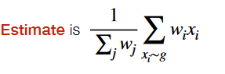
  + 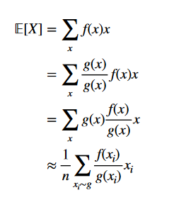
* Forward Sampling in Belief network
  + We know how to sample parts of a large joint dist in terms of other parts
  + Not able to directly sample from each conditional dist but not from joint dist
  + Steps:
    - Select an ordering of variables consistent with factoring
    - Repeat until enough samples generated
      * For each variable X in ordering

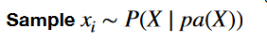

* While forward sampling generates a value for each variable then goes to next sample, particle filtering does revers
  + Generate n values for X, then n for Y
  + Each sample = particle
  + Weight updates value is sample
  + Periodically resample from particles with replacement and setting weights to 1
    - High probability to be repeated while loe probability are likely discarded
    - Cover dist better

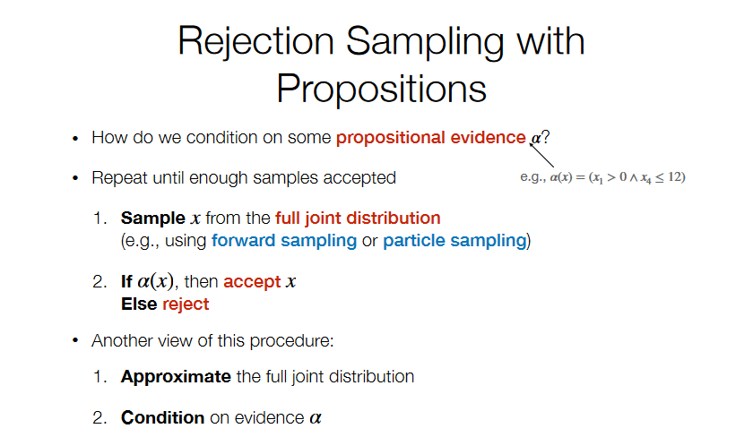

* In supervised learning, choose a hypothesis to minimize loss function
  + Loss(μ) = 1/n sum(yi - μ)2 where yi is the sample
* Optimization: Finding a value of x which minimizes f(x) i.e. x*= arg min f(x)
* Gradient descent: iteratively move from current estimate in the direction that makes f(x) smaller
  + Discrete = hill climbing, iteratively choose nieghbor that has minimim f(x)
  + Continuous domains, neighbourhood is less well-defined
* Derivates of f(x) is slope of function a point x, if greater than 0 as x increases grasient increase and while the oposite happens when gradient<0
* Linear Regression h(x:w) = w0+w1x1+w2X2

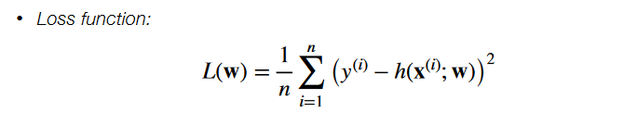

* Gradient of function is a vector of all partial derivates
* Gradient Descent: x_new= x_old – learning_rate*gradient of f(x_old)
* To get gradient:
  + 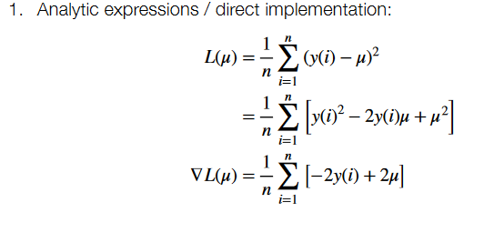 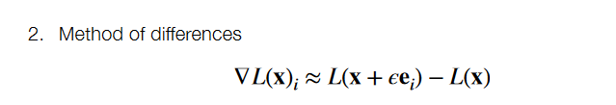
  + Chain rule for calculus
* Computers store real numbers as finite num of bits
* Real Nums encoded as floating point number
  + Single precision: 24 bits significand and 8 bit exponent
  + Double precision: 53 bit significand and 11 bit exponent
* Underflow:
  + 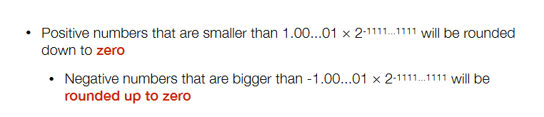
* Overflow:
  + 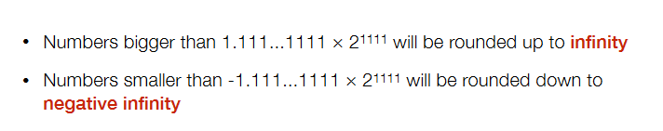
* Adding small numbers to large number can sometimes have no effect
* Softmax converts a vector of activations(numbers) into probability dist
  + 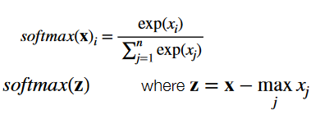
* Data set likelihoods shrink exponentially quickly in number of data points thus use log probabilities
* Use standard libraries
* 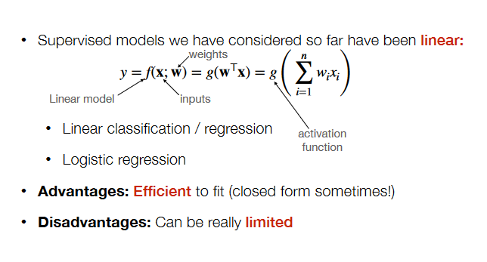
* XOR is not linearly separable so linear model can represent it
* One way is to use richer inputs
  + Define a feaute mapping phi(x) that returns functions of orignial inputs
  + Learn a linear model of features instead of inputs

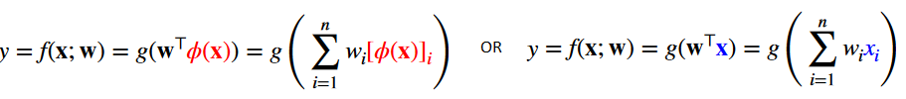

* Constructing god features are hard and aim of deep learning is to get phi automatically
  + Compse little functions called units
* Neural network is units composed together
  + Feedforard arranges them into layers with the outputs of previous layers taken into inputs for next layer
  + Think of outputs of each layer as a vector h
  + Weights from al outputs of previous layer to each of the units of layers form a matrix W
  + Offset term of unit can be collected into a matrix b (recall offset is h = g(Wx+b)
  + Decision to make:
    - No of layers
    - Num of nodes in each layer
    - Fully connected
  + Universal Approximation Theorem: A feedforward network with one hidden layer with a "squashing" activation or rectified linear activation and a linear output layer can approximate any function to within any given error bound, given  
    enough hidden units.
  + These are superivsed models and as such it is a function that takes an input x and computes y based on parameters p
  + 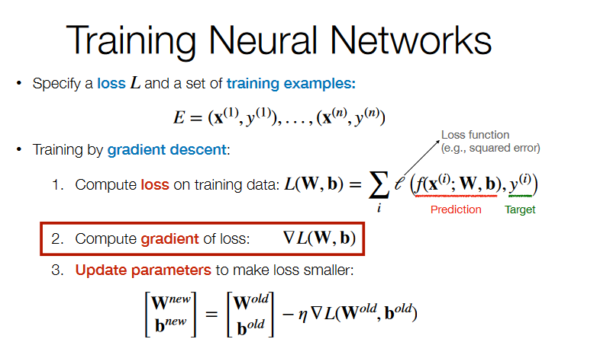
* ReLU (Rectified linear units) used for hidden unit activations doesn’t suffer from vanishing gradients.
* Function can be displayed as a graph, formula or finite numerical alg
* Differentiate a nested formula b recursively applying chain rule to derive a new formula for gradient
* Forward Mode:
  + Converts a finite numerical alg for computing a function int an augmented finite numerical alg for computing functions derivative
  + For each step, a new step is constructed representing derivate of corresponding step in program and to get partial derivate set s1’ and s2’ to 0 and run augmented alg
  + Looks of calculations
  + To get full gradient of a function of m inputs, requires getting m partial derivates
  + M forward passes
  + Thousands of parameters so lots of calculations
  + Sweeps through graph
  + Numerator varies and denominator is fixed for 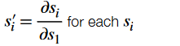
* Backwards Mode
  + 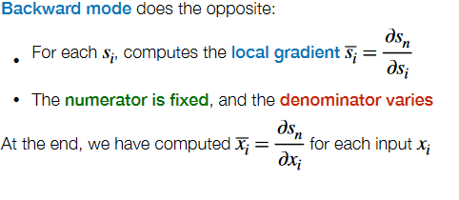 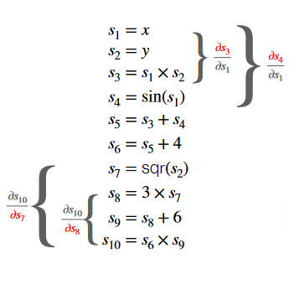
* Back propagation is automatic differentiation in backwards mode and used to get gradient of loss function w.r.t its parameters W, B
  + Each layer get local gradient of layers computations
  + Local gradients will be used as inputs to next layers local gradient
  + We have a partial derivate for each of parameters which can be used to take a gradient step
* Image classification: Recognize a handwritten digit from image. Can used neural to solve this
  + Large number of parameters in a larger image
  + Inputs are nodes
  + Lots of training data needed
  + Want to generalize over transformations
* Covolutional Neural Networks are used for image recognition
  + Pooling and Convolutionsa are used
  + Efficient learning via:
    - Sparse interaction
    - Parameter sharing
    - Equivarient representations
* Sparse Interactions Idea:
  + 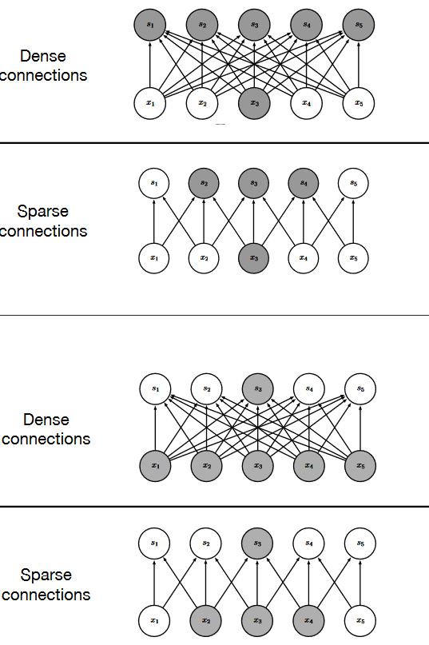
* Parameter Sharing: Constraining multiple parameters to be the same
* Equivariant Representation:
* Recognize transformed version of inputs we’ve seen without training for all transformed images
* Matrix product represents activations
* Convolution scans a small block of weights(kernel) over elements of inputs and takes weighted average
  + I/O dimensions don’t need to match, and same weights can be used for different combinations
  + Can be used to replace matrix multiplication as inputs only combine with neighbors and Same kernel for entire input
  + Steps
  + 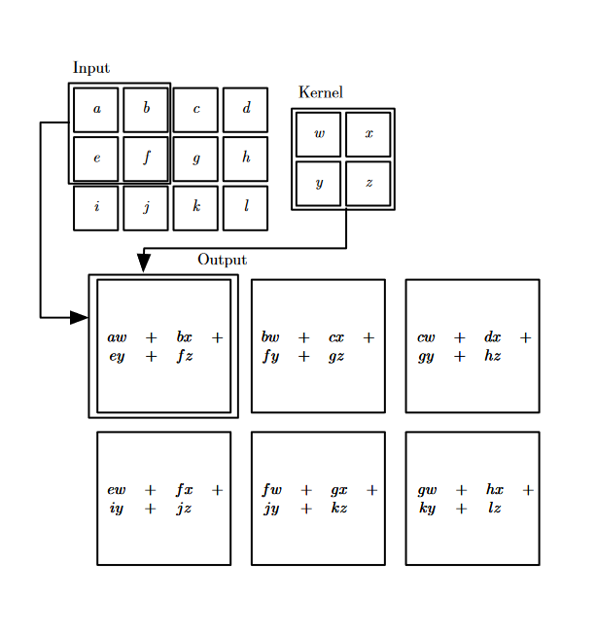
  + 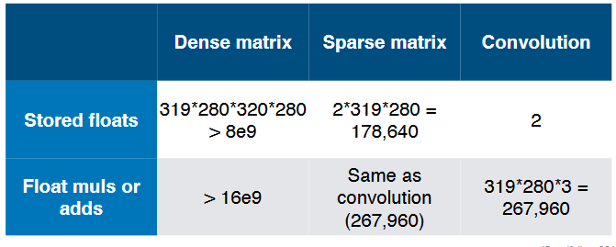
* Pooling:
  + Summarizes inputs into single value (Max, Avg)
  + Max-pooling has no parameters
  + Convolution🡪Pooling is called a convolution layer
* May want to model behaviour of sequences
* To represent sequential input to neural network
  + 1-hot vector for each word
  + 1-hot vector for last few words
  + Single vector indicating each word that Is present
  + Single vector summing semantic embeddings
* Dunamic system is a system whose state at time t+1 depends on state at time t s.t.
* St = f(st-1 ; theta)
* An expression which depends on same expression at earlier time is recurrent
  + Unfolding converts a recurrent expression into a non recurrent one
  + S(3) = f(s2;theta) = f(f(s1;theta);theta)
* Dynamical systems can also be driven by external signals St = f(st-1 , x t; theta)
  + Represented by non-current.unfolded computations
* Recurrent Neural Network: Specialized architecture for modelling sequential data
  + Input: One element at a time
  + Parameter sharing done by:
    - Treating sequence as a system with state
    - Introducing hidden layers which represent state
    - Computing state transitions and output using same functions at each stage
* Hidden units: Sequence to sequence
  + Input values x connected to hidden state h by weights U
  + H is then mapped to output o by wights V
  + Hidden state ht-1 connected to hidden state ht by weights W
  + Gradients computed by back propagation
  + All hidden states must be stored for gradient computation
* Sequence to single output
  + Update state as inputs
  + Only compute single output at end
  + W,U still shared at every stage
  + Evaluate every state in gradient computatution
* Can combine appraoches for sequence to sequence
  + Entire input as a single context C and construct a new sequence using C as only input
* Can have recurrence go from output at t-1 to hidden at t instead of hidden to hidden but less general
* Dependence on previous step is only on output not hidden state
  + Loss gradient depends only on a single transition
  + Raining can be paralleized(No need to compute previous step to get cururrent state)
* Info sometimes needs to be accumulalted for a long part of the sequence
  + How long an individual piece of info should be accumulated is context dependant
  + Often need to forget later
* LSTM network replace regular hidden units with cells
* Input feature computed with regular neuron
* Feature accumulates into state only if input gate allows
* State decays according to value of forget gate
* Output can be shutoff by output gate
* Reinforcement learning🡪 agent learns how ro act based on feedback from environment
  + Actions may change environment
  + Episodic or Continuing
  + Makes decisions online: Determines how to act while interacting with environment
* At time t
  + Agent receives input denoting current state St
  + Agent chooses action At
  + Agent receives reward Rt+1 and new State St+1 according to p(s’ ,r | s , a )
  + Interaction between agent and environment produces trajectory S0 A0 R0, S1 A1 R1….
* Markov decision process is a tuple (S,A , R, P) WHERE
  + S IS SET OF STATS
  + A is set of actions
  + R ∈ ℝ is set of rewards
  + p(s’ ,r | s , a ) ∈ [0,1] defines dynamic of process
  + probability from p completely characterises the environment’s dynamics
* 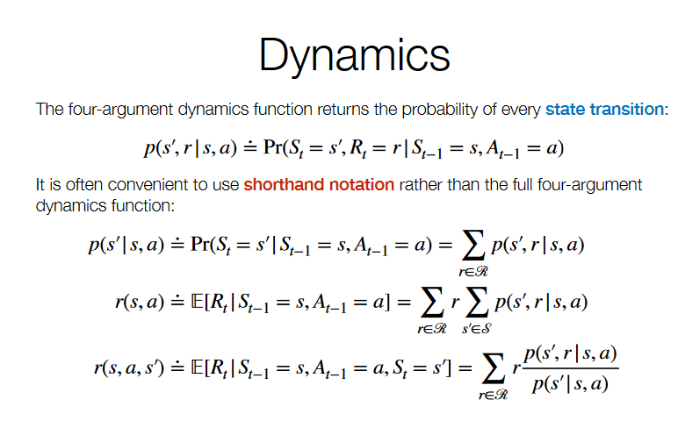
* Reward hypothesis: Agents goals and purposes can be entirely represented as max of expected value of cumulative sum of scalar signal
* Episodic task: Ends after some finite number T of time steps in a special terminal state St
  + Return Gt after time t is the sum of rewards received after time t.
    - This is a random variable and in episodic tasks we want to max its expected value
* Continuing Task: Does not end
  + We max discounted reurn and reurns are recurxivelt related to each other
  + 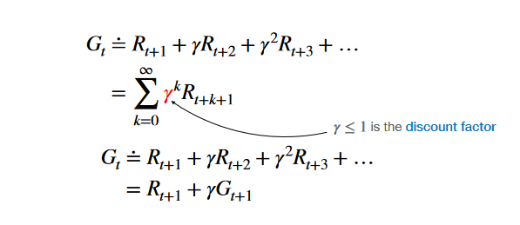
* Markov Assumption: State incorporates all necessary info about history up until current point
  + Chooses actions based only on St

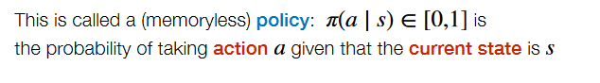

* + Once we know policy π and dynamics p, we can compute probability of every possible state transition starting from given state
  + Often important to know expected return starting from a given state under a given policy π as it tells you how good the policy is for a given state
  + State value function
    - 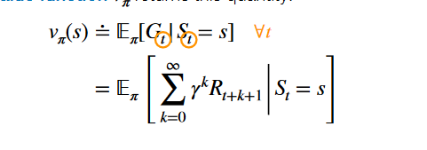
  + If a given state transition is deterministic, it is not necessarily the case the we choose the action leading to the next state s’ with highest vπ­ ­(s) as we need to take into account the reward
* Action value function qπ (s,a) estimates expected return Gt starting from state s if we
  + Take action a in state St =s and then follow policy π for every state St+1 afterward
  + 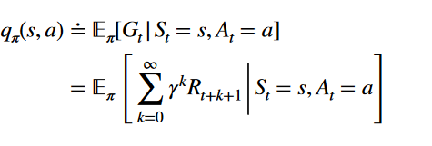
* 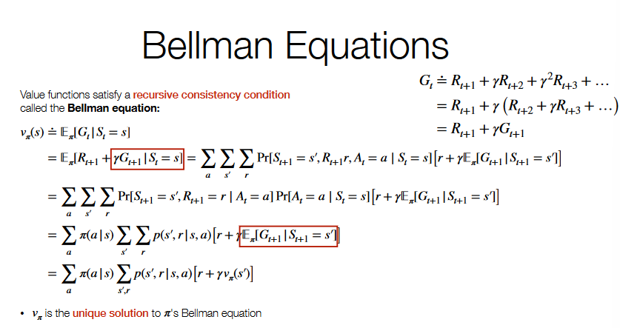
* Backup diagrams help visualize the flow of info back to a state from successor states or actions-state pairs
* 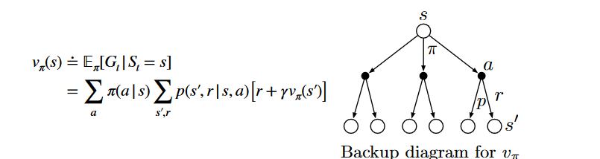
* We can compute vπ by amethod known as iterative policy evaluation
  + Uses Bellman equation as an update rule where vπ is a fixes point in update. As we start from an arbitrary v0, it will converge to vπ as k increases
  + 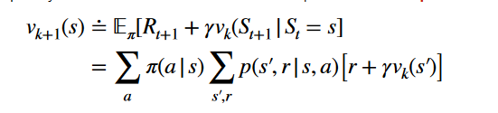
* 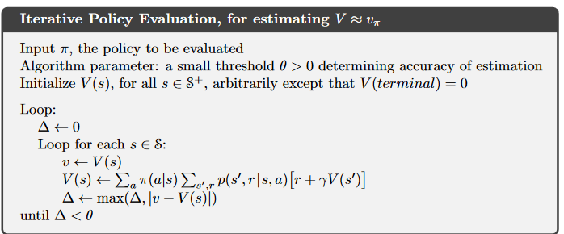
* Updates occur in place( use new values of V(s) immediately) as we would automatically want to use the new value immediately and as it will converge either way.
* Expected updates: Based on a weighted average of all possible next state
* Optimal policy is a policy which is weakly better than every other policy
  + A policy is better than another if it is better for all s in S
* Guaranteed to exist for every MDP
* All optimal policies share the same state-value function and same action-value function
  + A
* V* must satisfy the Bellman equation too and can be written in a policy free way as we know that every state value is maximized by π*
* 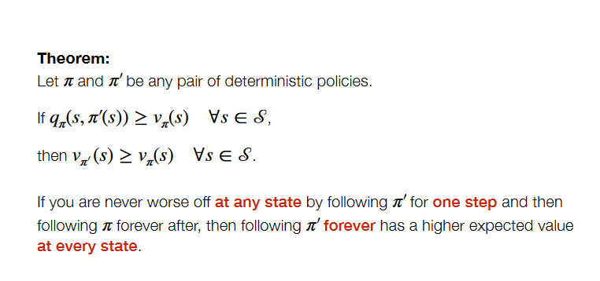
* Given any policy π, we can construct a new greedy policy π’ such that it is guaranteed to be at least as good
  + If new not better than old, Vπ (s)= Vπ’ (s) for all s in S
* Value iteration interleaves estimation and improvement steps
  + 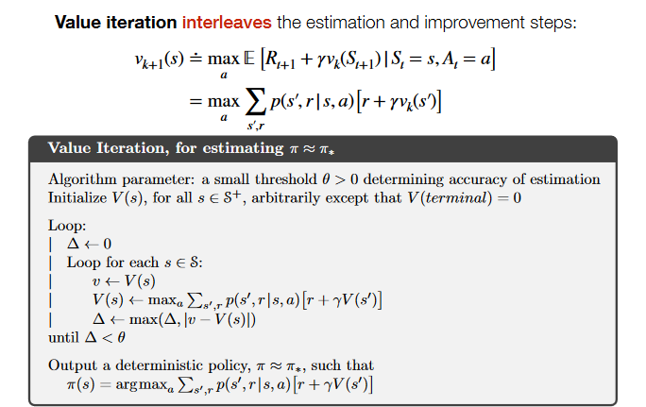
* Optimal policy has a higher state value than any other policy at every state
* Policy’s state value function computed by iterating an expected updated based on Bellman equation
* We can get a greedy improvement π’ by choosing highest expected value action based on vπ
* Policy iteration: Greedy improvement using vπ then recompute it and repeat
* Value iteraction: Recompute vπ by assuming greedy improvement at every update
* In order to compute expected updates, we need to know exact prob of every possible transition
* Sometimes don’t have access to full probability dist but we have access to samples of experience
  + Actual Experience: Learn based on inteeractions with a real environment without knowimg dynamics
  + Simulated: Simulate dynamics but don’t habe an explicit representation of transition probabilities or too many states
* We can estimate expecteation by averaging over sample drawn from dist
* 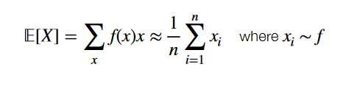
* Use a large sample of epsiodes generated by policy π to estimate state values vπ(s) for each state s
* 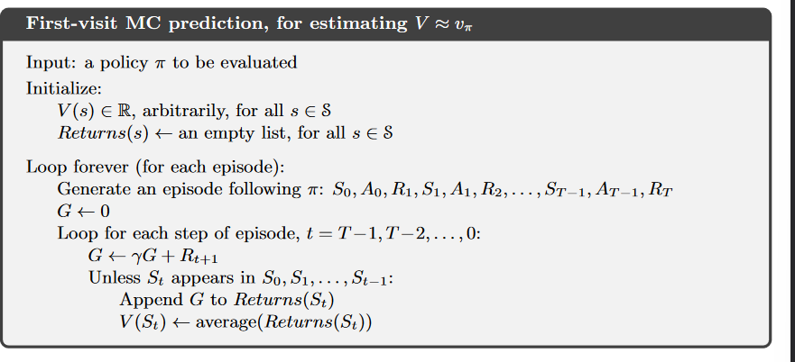
* Iterative policy eval uses the estimates of the next states value to update value of current state and as thus only needs to compute a single transition to update a states estimate
* Monte Carlo (MC) estimate of each state’ calue is independent from estimates of other states’ values and needs entre episode to compute and if desired can be focused on evaluation a subset of sttes if desired.
* Prediction is the process of estimating the value of states and/or actions given a fixed policy π
* Control is the process of estimating an optimal policy
* If we know the dynamics p(s’, r | s, a ), state value estimate is suffience to know if we have a good policy or not but if we don’t, the the state values arenot enough
  + Know dynamics:
    - Choose action which gives best combination of reward and next state value by doing: 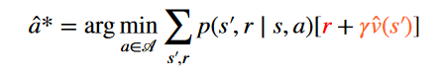
  + Don’t know dynamics
    - Need explicit estimate of action values
* First visit monte carlo allows us to approximate the returns to each state action pair but if the current policy doesn’t select an action from a state, we can’t estimate it’s value
* Every episode starts at a random state-action pair S0, A0 and every pair had a +ve probability of being selected at start
* Monte Carlo Control is used for policy iteration
* 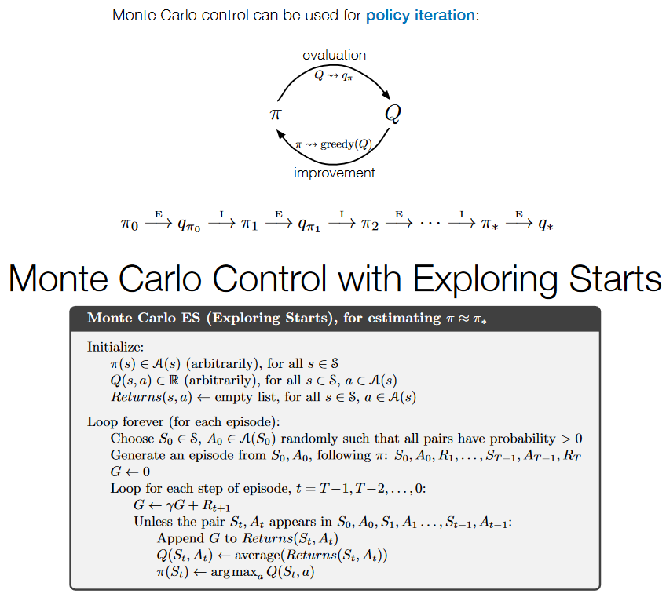
* Exploring start assumption requires us to see every state-action pair with a +ve probability even if we never choose a from s
  + Sometimes force the policy to choose an action
* 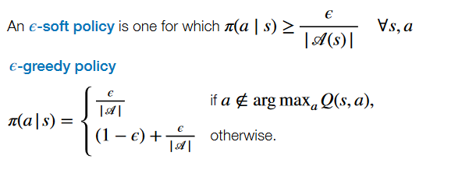
* 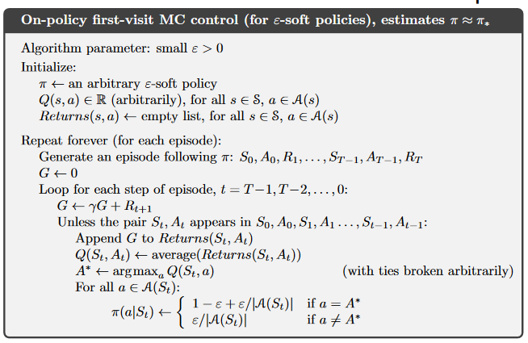
* Not guaranteed to converge into the optimal policy as it will construct an epsilon greedy policy but the optimal policy is not epsilon greedy as it only gives +ve probability to optimal actions.
* Monte Carlo Sampling: Use samples from target distribution to estimate expectations
* Importance Sampling: Use samples from proposal distribution to estimate expectations of target distribution by reweighting samples
* 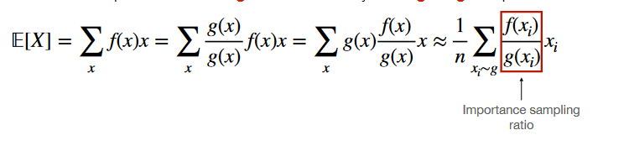
* Off policy learning Use data generated by a behaviour policy(proposal dist) to learn about a distinct target policy(target policy)
* Off-policy Monte Carlo Prediction
  + Generate episodes using behaviour policy b
  + Take weighted average of return to state s over all episodes containing a viit to s to estimate vπ(s)
    - Weighted by importance sampling rate of trajectory starting from St=s until end of episode:
    - 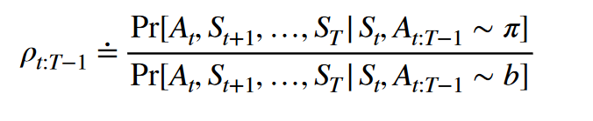
* 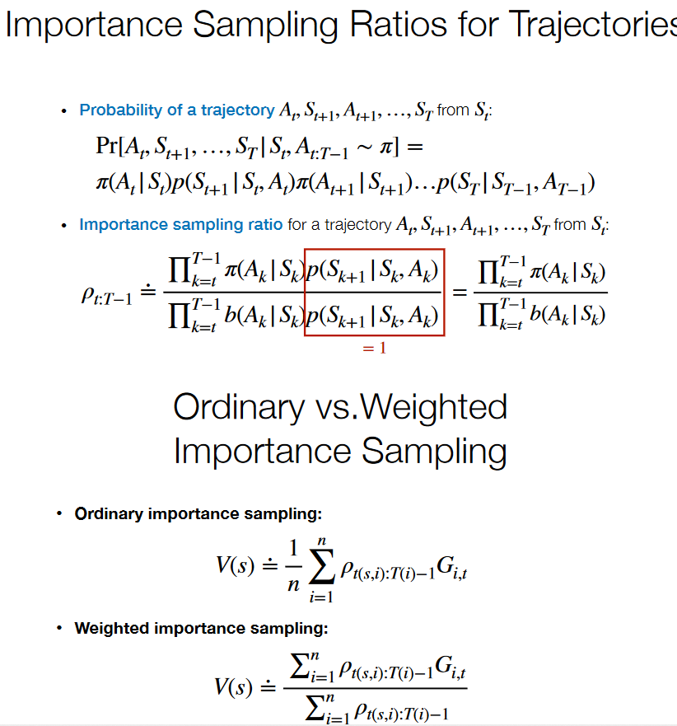
* 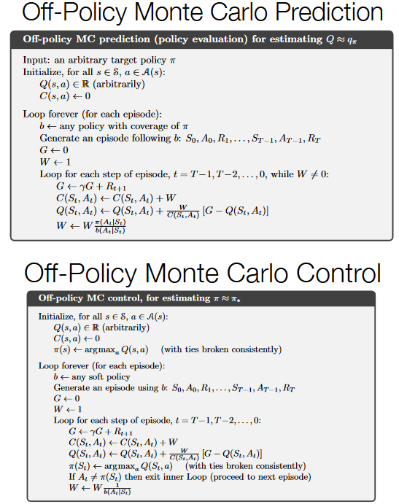
* 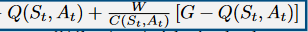 🡪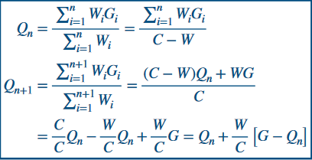
* Off Policy Monte Carlo Control will converge to the optimal policy π* as the policy we learn is deterministic and as long as we estimate Q values for it, we learn a policy greedy to the previous estimated target policy we learn and eventually will converge.
* We break when At is not equal to π(St) as weight will be 0 in trajectory
* Weights W does not involve π(At | St ) as we assume π is deterministic( assign 1 to greedy action and 0 to everything else)
* If we return action we chose, we can add a 1 to it
* Dynamic programming bootstraps: Each iterations estimates are based partly on estimates from previous iterations
* Each MC estimate is based only on actual returns
* Dynamic Programming” Require full dynamics and bootstrapping
* Temporal Difference (TD) : Learns from experience and Bootstrapping
* MC: Learns from experience but no bootstrapping
* 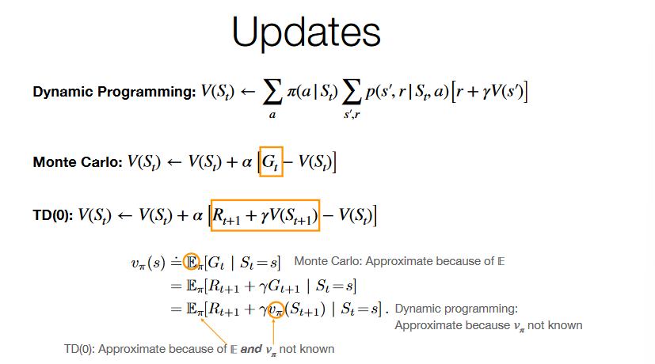
* 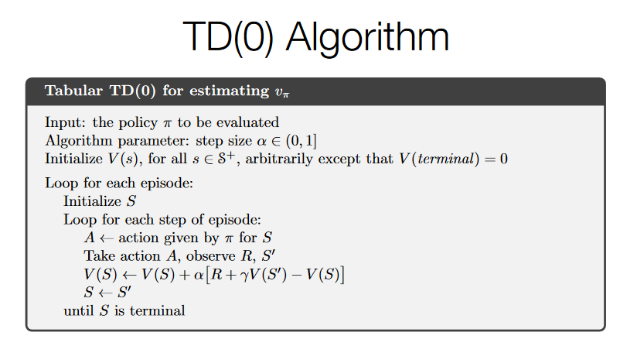
* This algorithm needs to know estimated value of current state, needs to know some actual action(chosen by policy) and estimate of value of next state and reward it realizes from transition
* Can use TD prediction into generalized policy iteration framework
* MC control loop
  + Generate episode using estimated π
  + Update estimates of Q and π
* On policy TD control loop
  + Take action according to π
  + Update estimates of Q and π
  + 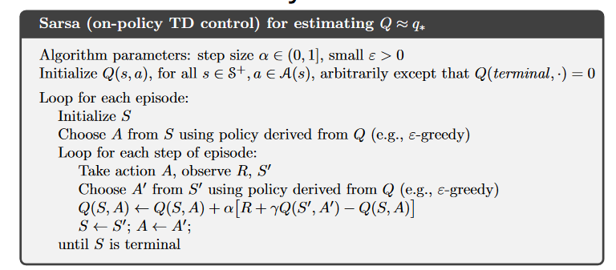
  + Needs to know estimate of action value
  + Not optimal policy as it chooses epsilon greedy action and estimated Q values are with respect to actual actions which are epsilon greedy
* 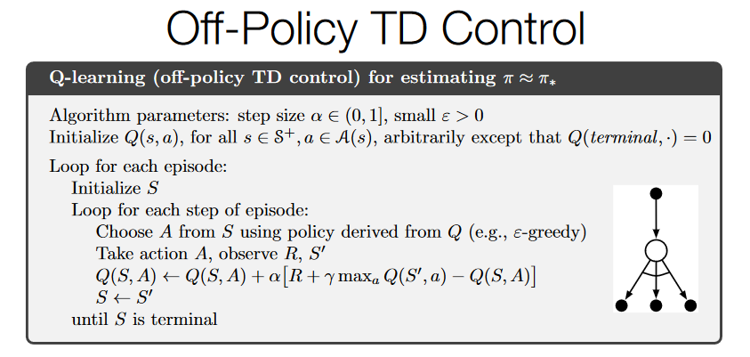
* Info needed is the q value for a given state and action and estimates action value of optimal policy while executing epsilon greedy policy.
* No π need as once we know Q values we know everything we need to know.
* We can separately set values of V(s) or Q(s,a) for all s∈S and a∈A
* Implicitly means we must store a separate value for every possible input for value function
* If there are too many states to store a value for each, we should pool the values(states with similar values) or use function approximation
* A parameterized calue functions’ values are set by setting the values of a weight vector w∈Rd
  + 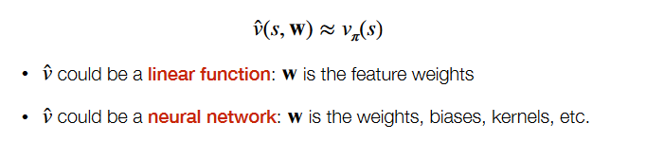
* Many fewer weights than states
  + Changing one weight changes the estimated value of many states
  + Updating a single state generalizes to affect many other states
* Tabular estimates:
  + Can update value of single state individually and estimates can be exactly correct for each state
* Parameterized estimates
  + Estimates can’t be necessarily correct for each state
  + Can’t independently adjust state values
* Trade off estimation quality of one state vs another as we cant guarantee every state to be correct
* Use a dist of μ(s) which allows us to specify how much we care about state value estimate quality
* Aim is to optimze the mean squared value error
  + 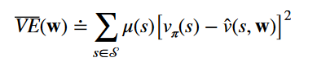
  + If we know vπ this turns into a supervised learning problem with a lose of VE
* We should use stationary distribution for μ(s) which is the distrbution over states
* Stochastic gradient descent: Adjust weights a tiny biy in direction which would reduce error on example
  + If we know true values then do the following 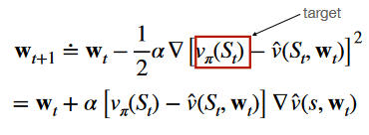
  + If unknown true values do this:
  + 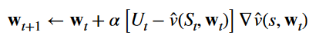
    - If we know vπ(S), we are done but instead here we update towards an approximate target Ut which can be any of out update targets
* Monte Carlo Gradient
  + 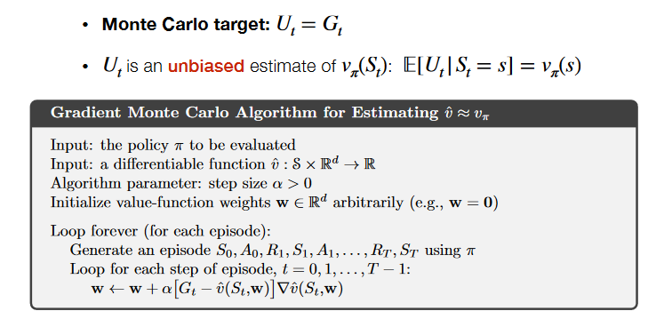
* Semi Gradient
  + TD(0) Target is 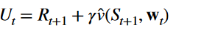Biased as bootstrapping targets like TD(0) depend on current wt value
  + The gradient $∇\hat{v}\left(s,w_{t}\right)$ accounts for change in estimate from change in wt
    - Updates to w change both target and estimate
  + 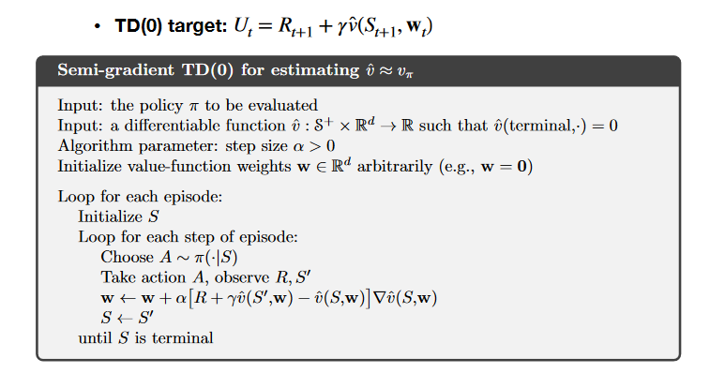
* Aggregate states together to reduce memory usage
* 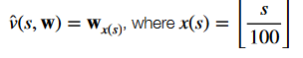
* Linear approximation
  + Every state is assigned a feature vector
 $x\left(s\right)=\left(x_{1}\left(s\right),x_{2}\left(s\right),…,x_{d}\left(s\right)\right)$

 + State-value function approximation:
    - 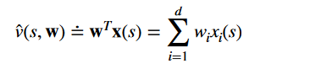
  + Gradient: 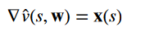
  + Gradient update: 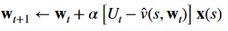
  + State aggregation is a special case of linear approximation
* Coarse Coding
  + Divide state space into overlapping cells
  + 1 indicator feature for each cell and set to 1 if state is in cell
  + State aggregation form
  + Updating a state generalizes to other states which share a cell
  + Tile coding is most practical form
  + Partition state space into a uniform grid called a tiling and we use multiple tilings which are offset
* Approaches to control
  + Action-value methods
    - Learn the value of action in each state qπ (s, a)
    - Pick the max-value action arg max of a qπ(s, a)
  + Function approximation
    - Prediction: Learn parameters w of state-value function $\hat{v}\left(s,w\right)$
    - Control: Learn the parameters w of action-value function $\hat{q}\left(s,w\right)$
  + Policy-Gradient methods
    - Learn parameters θ of a policy π(a ∣ s, θ)
    - Update by gradient ascent in performance
* The action probabilities of a parameterized policy π(a ∣ s, θ) are set by setting the values of a parameter vector θ ∈ ℝd
* Common approach: softmax in action preferences
  + Learn an action preference function h(s ,a, θ)
  + Softmax over action preferences gives action probabilities

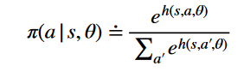

* Anything we could have used for $\hat{v}$
  + Linear approximations 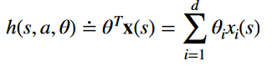
    - Including state aggregation, coarse coding and tile coding
  + Neural network: θ are weights, offsets, kernel etc.
* Optimal policy π*(a ∣ s) = arg max of a q*(s, a) is deterministic when no state aggregation
* If we run an epsilon soft policy, we cannot get to an optimal policy
  + Every action is played with either probability epsilon or 1-epsilon
* Softmax in action preference policies can learn arbitrary probabilities as h (s ,a , θ) is unconstrained
* When function approximation makes state look the same or when states are imperfectly observable the optimal policy might be an arbitrary probability distribution
* Parameterized policies can represent arbitrary distributions
  + Although not necessarily arbitrary distributions in every possible state
* We choose policy parameters to max performance of policy

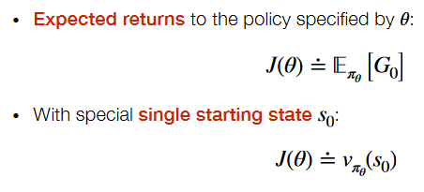

* Policy Gradient ascent
  + Max performance J(θ) = vπθ (s0)
  + Gradient gives direction j increases
  + Update parameters in direction of gradient
    - 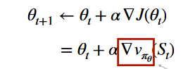
    - We do not know value of v nor its gradient
    - 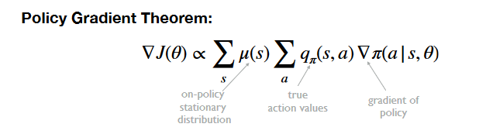
    - Gradient of policy is gradient of value function wrt to policy
  + 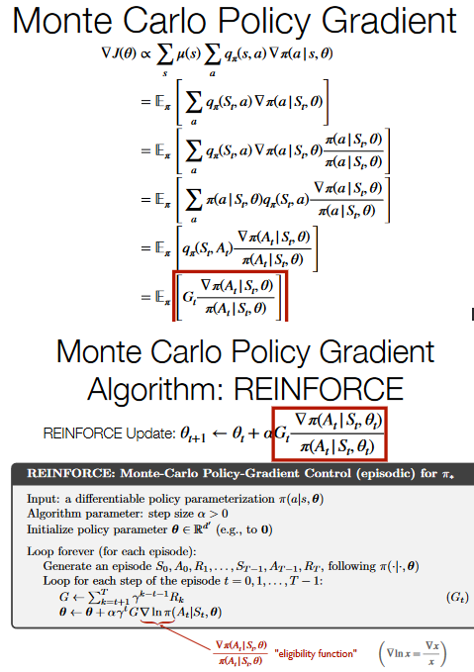
* Normal form game: Agents make a single decision simultaneously and receive a payoff depending on actions
  + N is a set of n players each indexed by i
  + A=A1*A2….*An is set of action profiles with Ai is the action set for player i
  + U = (u1🡪un) is utility function for each player where ui: A🡪R
* One example is prisoners dilemma
* Expected value of a scalar utility function ui: A🡪R is sufficient to represent rational preferences( Satisfy completeness, transitivity, substitutability, decomposability, monotonicity and continuity)
* Action profile determines the outcome in a normal form game
* Affine invariance: Given set of preferences, ui is not unique
  + U’i(a)= aui(a)+b represents same preferences for all a>0 and b ∈ ℝ
* In a zero sum game players have exactly opposed interests s.t U1(a)=-U2(a) but for pure cooperation games, they have the same interest s.t Ui(a)=Uj(a) for all a, I and j
  + Some games can be both cooperative and competitive
* Optimal Decision: A decision that maximizes agents expected utility
  + Multiagent setting: Incoherent as best strategy depends on strategy of others
* Cant compare agents utilities to each other due to affine invariance
* Solution concepts: Identify certain subsets of outcomes that are interesting in one sense or another
* An outcome o* is Pareto optimal if no other outcome Pareto dominates it
  + E.g. sometimes some outcome o1is at least as good for any agent as outcome o2 and as such some agent strictly prefers outcome 1 to 2. This is Pareto domination.
* The better action depends on what another agent does
* 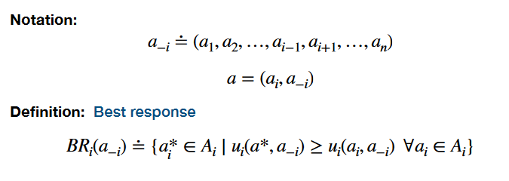
* Nash equilibrium is a stable outcome in which no agent regrets actions
  + Formal def: 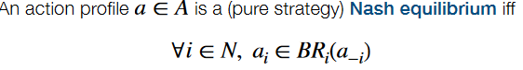
* A strategy si for agent I is any probability distribution over set Ai where each action ai is played wth probability si(ai)
  + Pure strat: only a single action is played
  + Mixed strat: Randomize over multiple actions
* Set of i’s strats: Si ≐ Δ(Ai)
* Set of strategy profiles: S=S1 x S2 x….x…Sn
* Utility of a mixed strategy profile:
  + 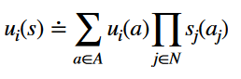
  + Ui(a) is utility action profile a and $\prod_{j∈N}{s_{j}\left(a_{j}\right)}$ is probability of profile a given all agents play according to s
* The set of I’s best responses to a strategy profile s∈S is the following:
  + 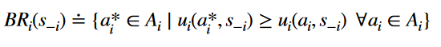
* A strategy profile is a Nash equilibrium if
  + 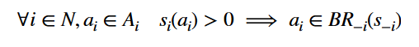
  + Note that is at least one si is mixed, s is a mixed strategy Nash Equilibrium
* Nash’s Theorem: Every game with a finite no of players and action profiles has at least one Nash equilibrium
  + Pure strategy equilibria not guaranteed to exist
* Mixed strategy Nash Equilibrium
  + Sampling sist in heads
  + Dist represents other agents uncertainty about what agent will do
  + Dist is empirical frequeny of actions in repeated play
  + Dist is frequency of a pure strategy on a population of pure strategies
* Pareto Optimal(Other def): no agent can be made better off without making some  
  other agent worse off
* Nash Equilibrium: no agent regrets their strategy given the choice of  
  the other agents' strategies
* All actions in normal form games occur simultaneously
* Extensive Form: Game representation including temporal structure like a game tree
  + Perfect information: Agents sees all actions of other player
  + Imperfect Info: Some actions are hidden
* Finite perfect info in extensive form is a tuple G=(N, A, H Z, χ, ρ, σ, u) where
  + N is a set of n players
  + A is a single set of actions
  + H is a set of non terminal choice nodes
  + Z is a set of terminal nodes(disjoint from h)
  + X:H🡪2Ais the action function
  + P:H🡪N is player function
  + σ : H × A → H ∪ Z is successor function
  + u=(u1🡪un) is a utility function for each player ui: Z🡪R
  + 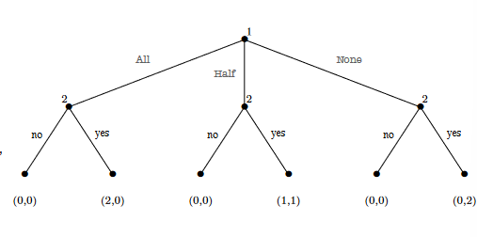
* Pure strategies in an extensive form game: Let G=(N, A, H Z, χ, ρ, σ, u) be a perfect info game in extensive form. Pure strategies of player consist of cross produce of actions available to player I at each of choice nodes.
* A pure strategy associates an action with each choice nod wven with this that will never be reached
* 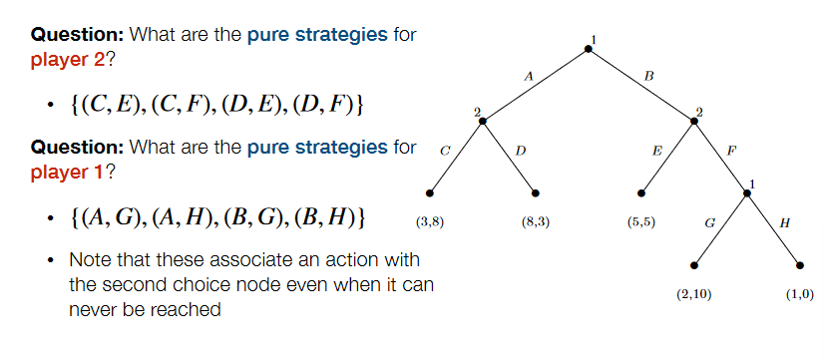
* Any pair of pure strategies uniquely identifies a terminal node which identifies a utility for each agent as once we know the pure strategies of both players, we can play towards it and we know the outcome.
  + Know defined set of agents, pure strategies and utility functions
  + Can turn an extensive form game into an induced normal form game
  + Most terminal forms show up more than once
  + Extensive form is more compact
* Mixed strategy is a distribution over pure strategies
* Best response is strategy that maximizes your expected utility given everyone else’s utility?
* Nash equilibrium a strategy profile where everyone is best responding to each other
* Every finite perfect info game in extensive form has at least one pure strategy Nash equilibrium
  + Starting from bottom of tree no agent needs to randomize as the know best response
  + Could be multiple pure strategy Nash equilibria in cases where agent has multiple best responses at a single choice node
* Backward induction is an algorithm which is guaranteed to compute a pure strategy nash equilibrium
  + Replace subgames lower in tree with equilibrium values
  + Not usually how people actually play
* Maxmin strategy for I is a strategy si which maximizes I’s worst case payoff
* Maxmin value for I in a game is the value vi guaranteed by a maxmin strategy
  + Formal defs:
    - Strat: 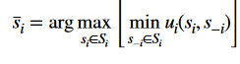
    - Value; 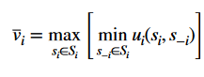
* Maxmin strategies are guaranteed to exist
* An agents maxmin strategy isn’t necessarily unique
* Agent would want to play a maxmin strategy because we want to aim for the least worst payoff possible as the other is aiming to give me the worst payoff
* Minimax theorem: IN any Nash Equilibrium s* of any finite, 2 player zero sum game, each player receives an expected utility vi equal to both their maxmin and their minmax value
  + 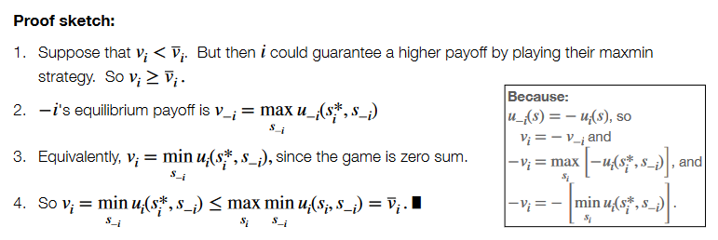
* In an zero sum game
  + Value of game: Each players maxmin value is equal to minmax value
  + For both players, maxmin strategies and Nash Equilibrium strategies are the same sets
  + Any maxmin strategy profile(both doing maxmin strats) is a Nash Equilibrium
* Perfect info extensive form games🡪Use backward induction to get Nash equilibrium
  + Note for centipede game, unique equilibrium is to play D at very choice and equilibrium choice is Pareto dominated
* IN general sum fame Maxmin strat isn’t necessarily equal to Nash Equilibrium whereas in a zero sum game ever Nash Equilibrium strat = Maxmin strat
  + Can regret Play Nash start against Non Nash strat
* Backward induction requires us to examine every leaf node
  + In zero sum, we can just prune trees( case of branch and bound)
  + Intuition is If a player can guarantee at least x starting from a given subtree h , but their opponent can guarantee them getting less than x in an earlier subtree, then the opponent will never allow the player to reach h
* 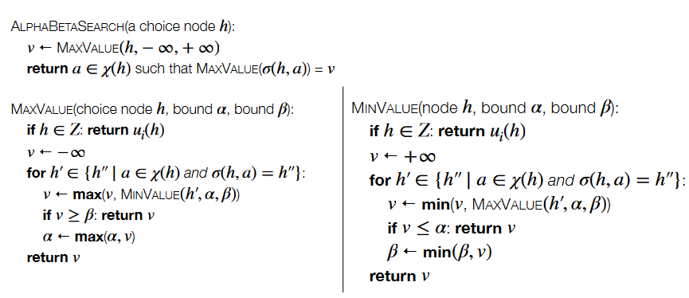
* Games can induce randomness in environment
* Include chance nodes owned by nature
* Need to tweak alpha-beta
  + Take expectation at chance nodes instead of min/max and prune based of bounds
* Notes about alpha beta
  + This algorithm will not work with arbitrability deep game trees as we need a bounded depth to find utility of going down branch and we put those in terminal nodes
  + Will not work for non-zero sum nodes